Eastern Washington University

SAP Concur Request Quick Guide

Table of Contents
Creating and Submitting a Request 2
Adding Travel Allowances to a Request 6
Requesting a Cash Advance 9
Creating a Group Travel Request 12
Printing and Submitting a Request Report 14
Approving Requests 16
Adding a Request to an Expense Report 19
Closing a Request 21

Creating and Submitting a Request
Using Concur Request, you can submit an authorization request with your expected trip expenses prior to booking a trip in Concur Travel.
To create and submit a request
- From the SAP Concur home page, on the Quick Task bar, place your mouse pointer over New, and then click Start a Request.
- On the Create New Request page, complete the required fields (indicated with a red asterisk) and any optional fields, and then click Create.
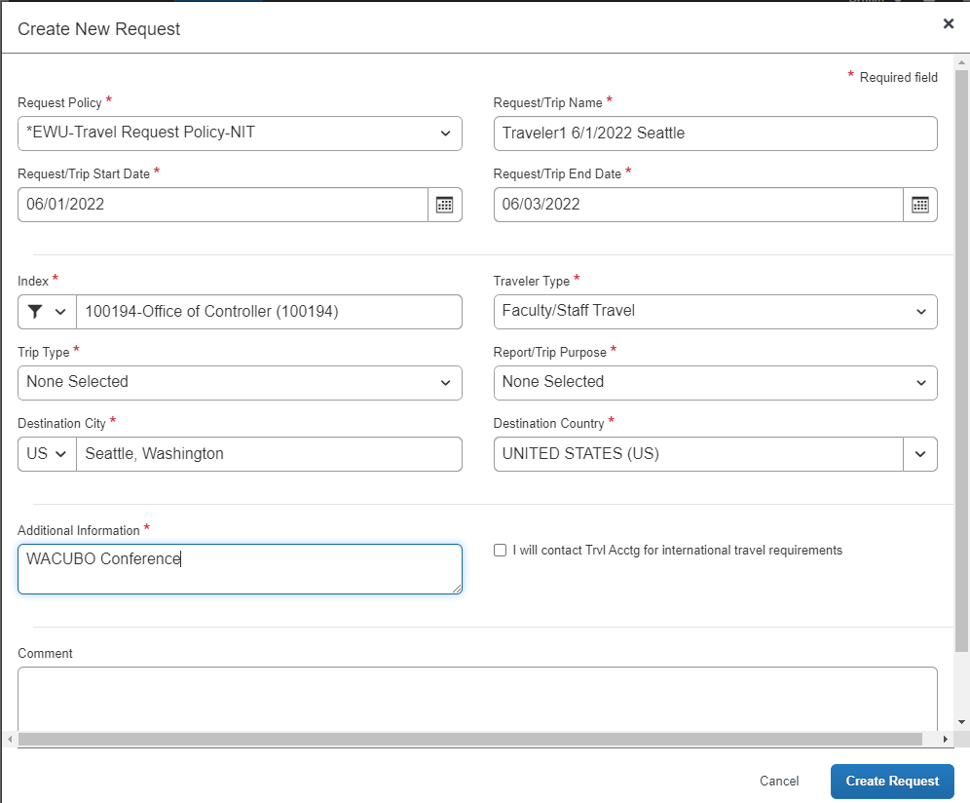
- On the Expected Expenses page, click Add to enter your trip details and estimated amounts for each expense.
The most common expense types are airfare, car rental, and hotel.
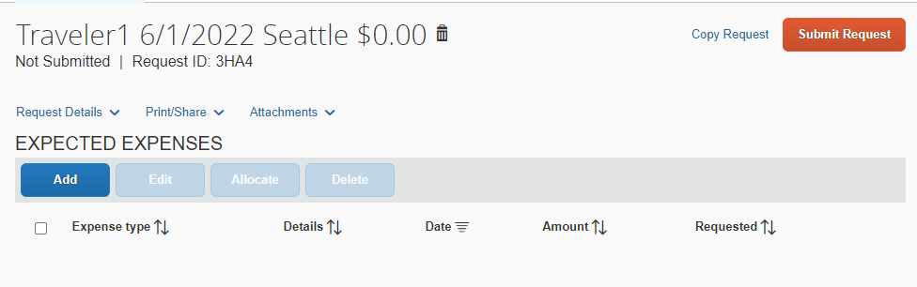
- In the Expense Type dropdown list, search for and select the appropriate expense type.
For this example, you will see how to add your conference fees.
- Select Seminar/Conference Registration Fees.
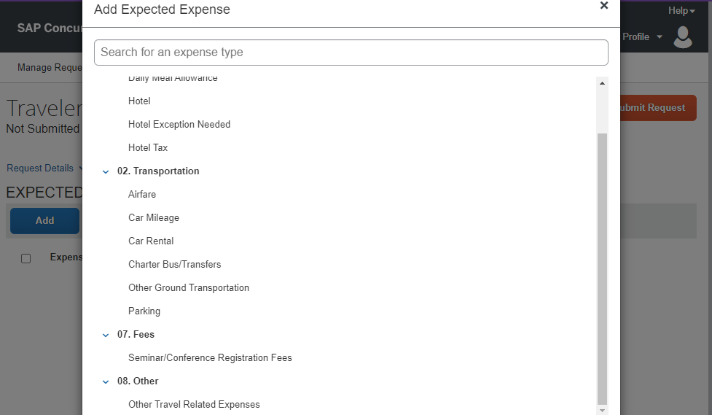
- On the New Expense page, complete the required and optional fields, and then click Save.

If the expense is to be paid by travel accounting or by the department, click the Pay by Travel Accounting checkbox or the Pay by Department checkbox.
Attach registration or booking details, or an invoice, and forward as needed for action.
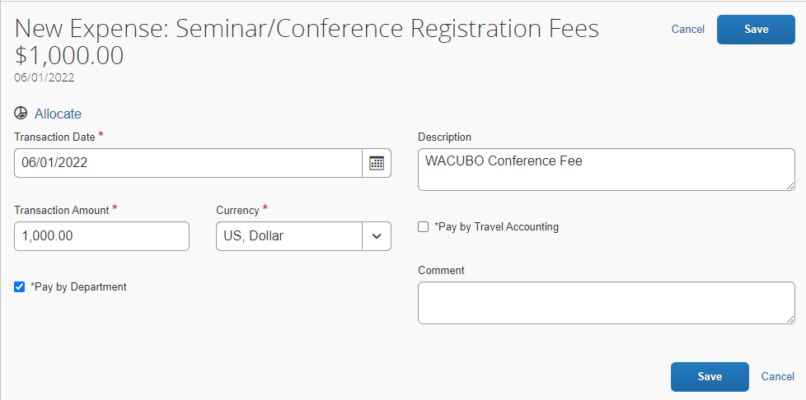
- Continue to add your expected expenses for the request.
- After you enter your expected expenses, click Attachments to attach the appropriate documents for your approver’s review.
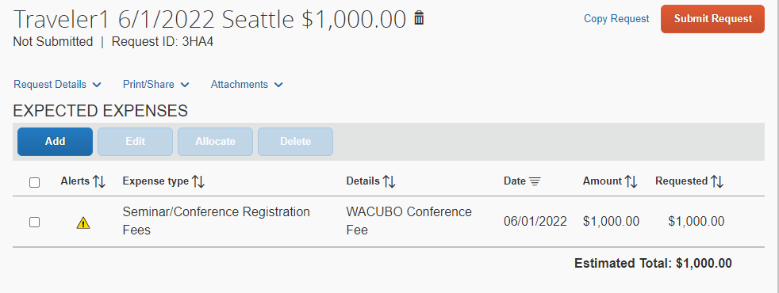

- Click Attach Documents, and then in the Document Upload and Attach window, click Upload and Attach.
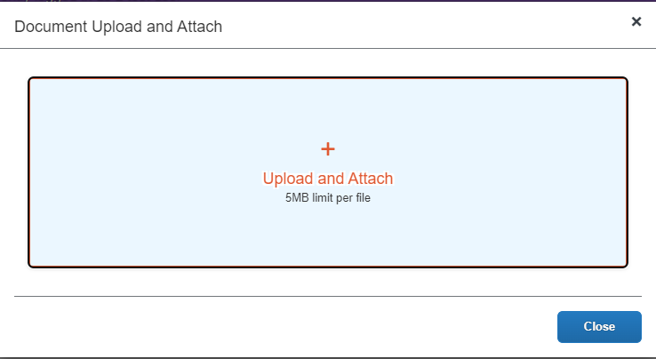
- Select the file you want to upload and then click Open.
- After you complete your expected expenses, click Submit Request.
The authorization request is submitted and pending approval.

Adding Travel Allowances to a Request
You can add expenses to your request to help estimate the total cost of your trip travel allowances for lodging and meals.
To add travel allowances to a request
- On the Expected Expenses page, click Add to enter your trip details and estimated amounts for each expense.
In the list of expense types, you will see Daily Meal Allowance and Hotel. These expense types are configured to calculate a per diem amount based on the arrival city and duration of your trip.
- For this example, click the Daily Meal Allowance expense type.
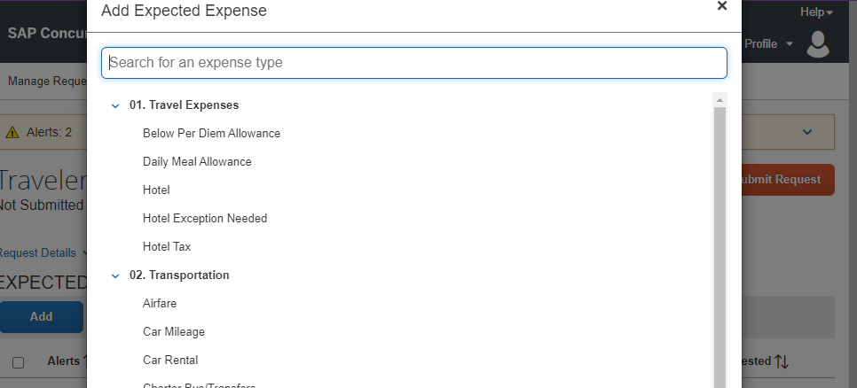
- Enter the Trip Start Date, Trip End Date, Destination City, and # of Days at This Location.
- NOTE: The Transaction Amount field is read-only and is automatically populated based on the city, duration of your trip, and the per diem rate calculation for the arrival city.

- Click Save.
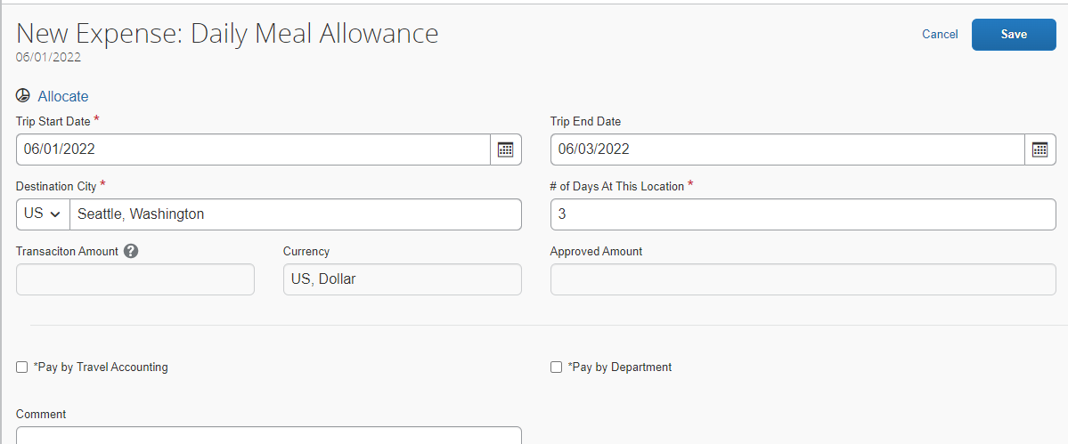
After saving the expense, the calculated Amount based on the fixed allowance is displayed.
- NOTE: The full amount of daily allowance is set in the report and will require an additional expense line item (Below Per Diem Allowance) to subtract meal periods for starting or ending travel status between assigned meal periods or meals that were provided at the event.

- Click Add, and then click Hotel.
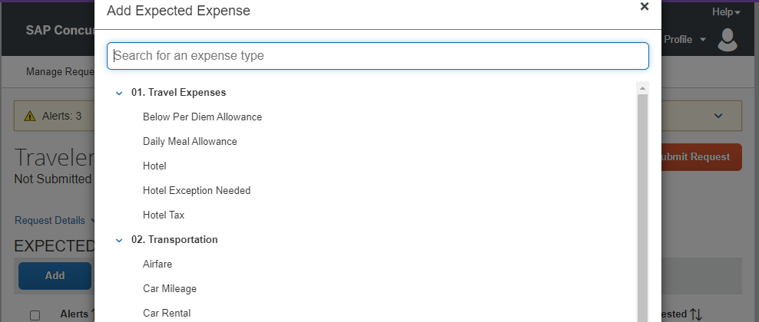
- Complete the appropriate fields, and then click Save.
- NOTE: The total expense is based on the standard lodging rate. If the actual or estimated lodging rate is less than the standard rate, an additional expense line item (Below Per Diem Allowance) to subtract the difference may be used.
- If the actual or estimated rate will be greater than the standard rate, an additional expense line item (Hotel Exception Needed) may be used to report the difference that is more than the standard rate. A Hotel Exception reason is required.
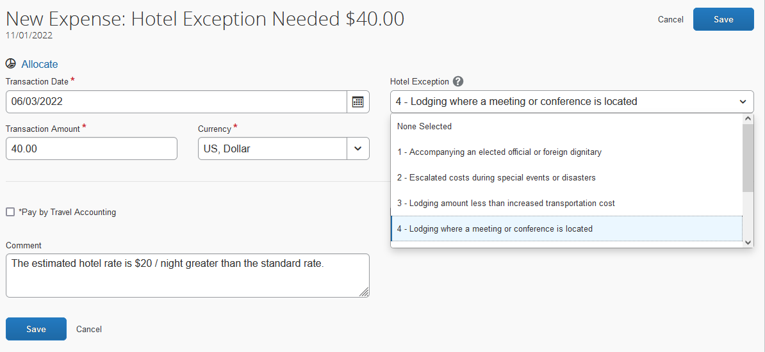

- After entering your expenses, click Submit Request.
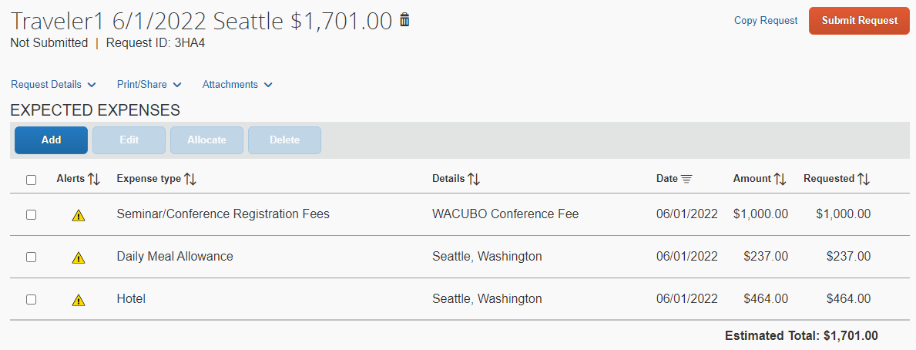
Your request is submitted and waiting for approval.

Requesting a Cash Advance
You can request a cash advance for an upcoming business trip. Not all expense types are eligible for cash advances. Only one cash advance per trip is allowed. You must account for your entire cash advance with an expense report upon return.
To request a cash advance with a request
- On the Expected Expenses page, click Add to enter your trip details and estimated amounts for each expense.
- Add all expected expenses and click Save.
- Click the Request Details dropdown menu, and then click Add Cash Advances.
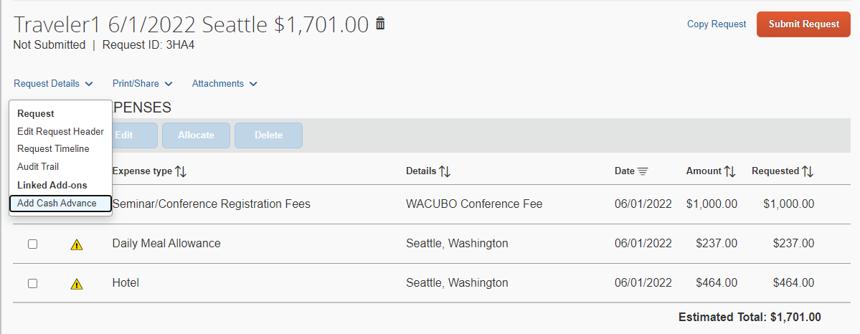
A Cash Advance box appears on the request report page and the allowable amount for a cash advance is displayed.

Some expense types are not cash advanceable, reducing the cash advance.
In this example, expense type Airfare is not cash advanceable and is not included in the amount.
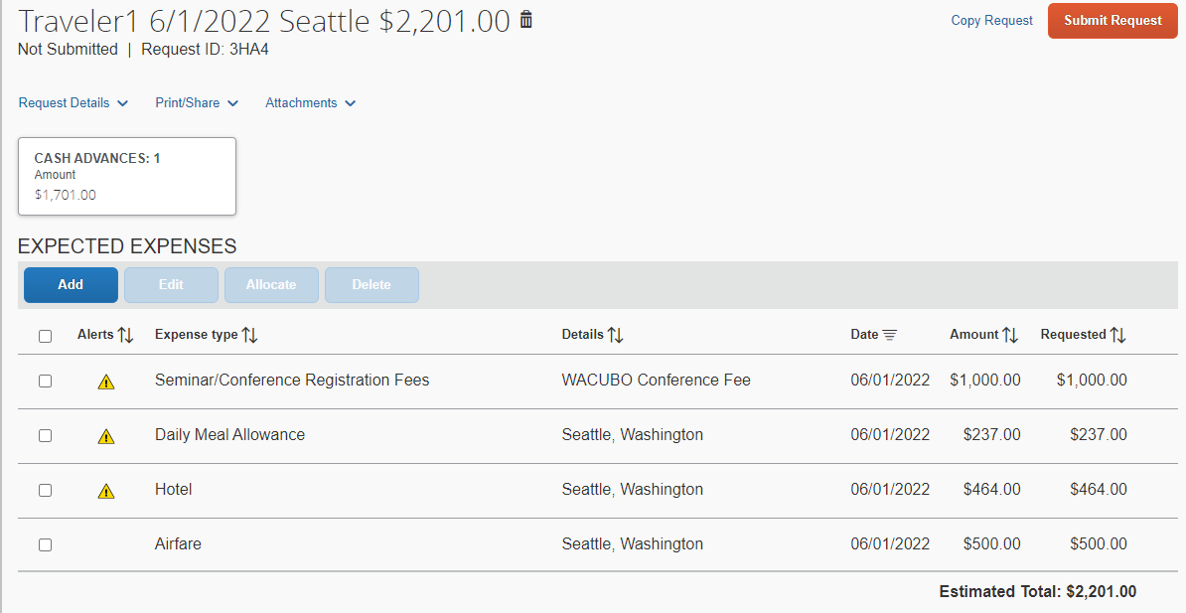
- Click on the Cash Advances box to open the details.
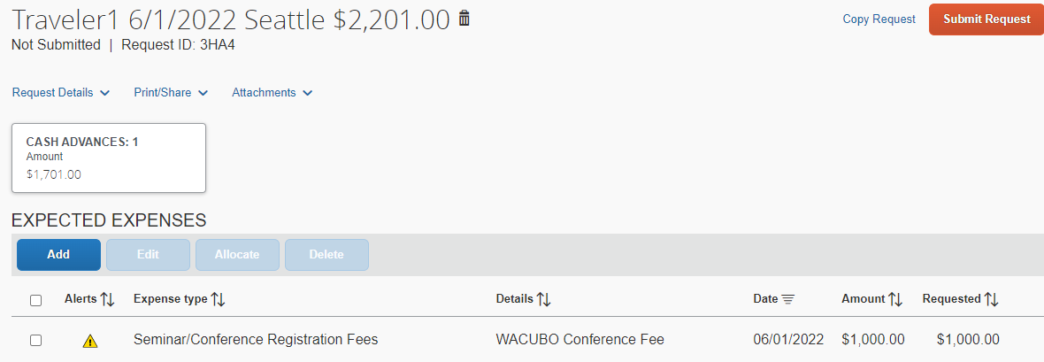
- Reduce the Cash Advance Amount by any expense that was marked Pay by Travel Accounting or Pay by Department and click Save.
In this example, Seminar/Conference Registration Fees was marked Pay by Department.
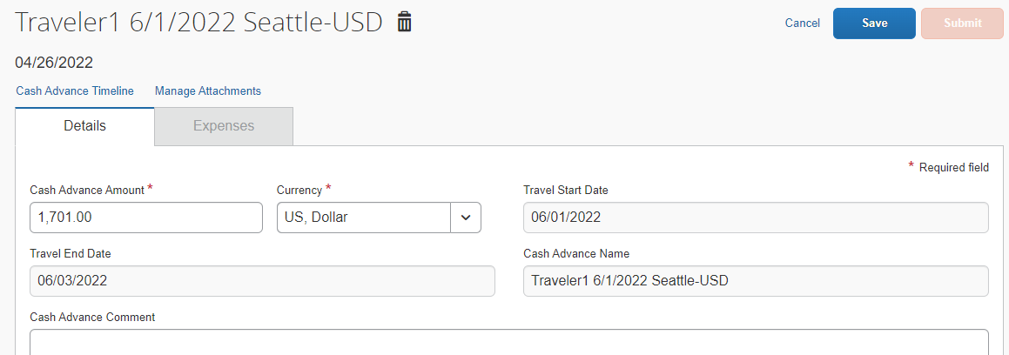
Reduce 1,701 by 1,000.
Enter Cash Advance Amount as 701.

- Attach any required documents and click Submit Request.
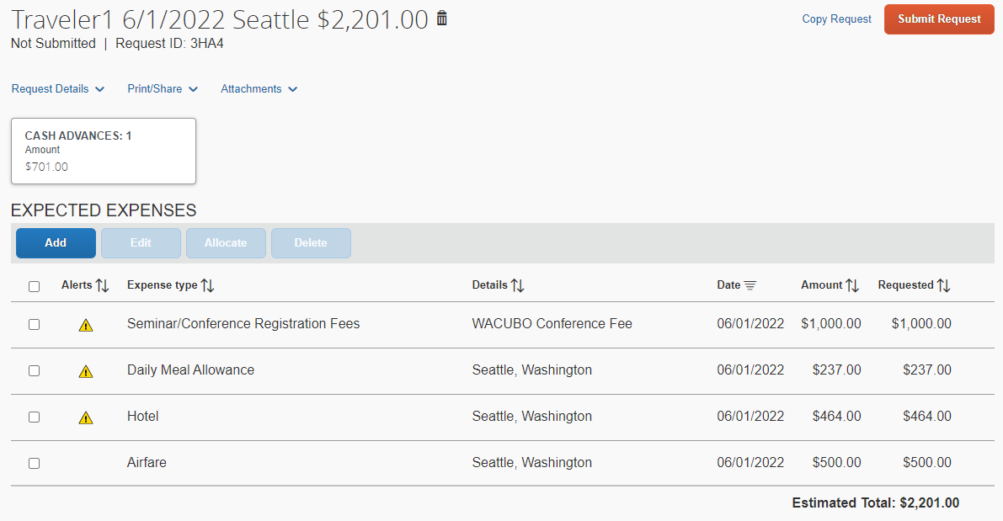
The request with cash advance is submitted and pending approval.

Creating a Group Travel Request
Group Travel has more than one person traveling on the same trip with one request and expense report. It requires the use of a separate travel policy called * EWU-Group Travel Request Policy-NIT. It also includes a few unique expense types specifically created for a group situation. These include:
  - Hotel Group
  - Group Meals/Entertainment
  - Food Products-Grocery/Bulk (Team Snacks)
All other expense types are the same.
Group travel does not use the Travel Allowance and Itinerary function as individual travel does. It is important to select the appropriate travel policy to provide for these unique situations of group travel before navigating through the remaining header fields.
Visit the Travel Accounting site to familiarize yourself with Travel Requirements for Groups (https://inside.ewu.edu/financialservices/office-of-controller/travel-accounting/travel-requirements-for-groups/).
To create a group travel request
- From the SAP Concur home page, on the Quick Task bar, place your mouse pointer over New, and then click Start a Request.
- Click the dropdown arrow for Request Policy and select *EWU-Group Travel Request Policy-NIT and enter the Number of People Traveling.
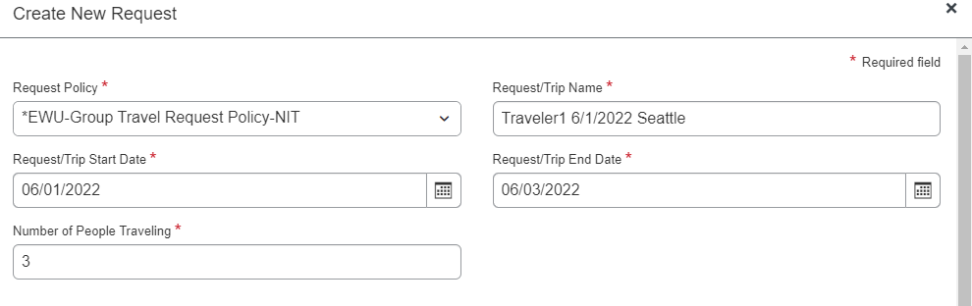

- Change Traveler Type to Team/Group Travel, fill out the remaining required and optional fields and click Create Report.
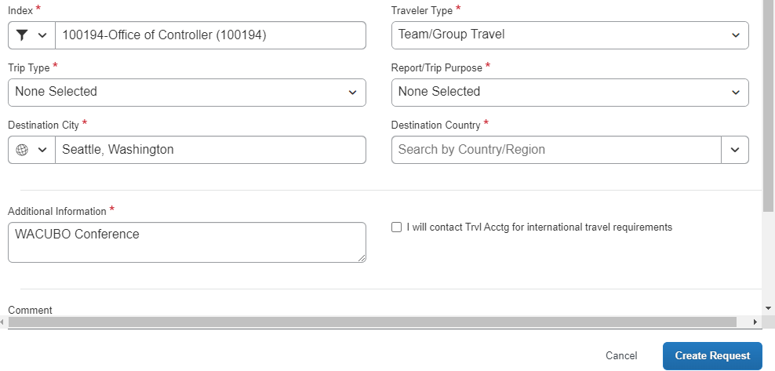
- Continue inputing expected expenses as with individual travel requests.
Refer to the Creating and Submitting a Request section, and any other needed sections above.

Printing and Submitting a Request Report
When you complete your request report, you can print it to save a hard copy for your records. It is highly recommended that you save a copy to assist in preparing your expense report upon return.
To preview and print the request report
- On the request report page, click Print/Share, and then select EWU-Request Printed Report.
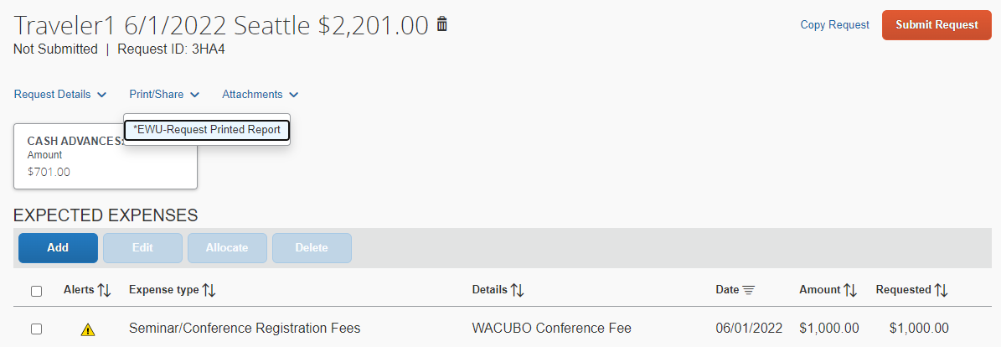
- On the Detailed Report screen, review the details, and then click Print, Save as PDF, or Email.
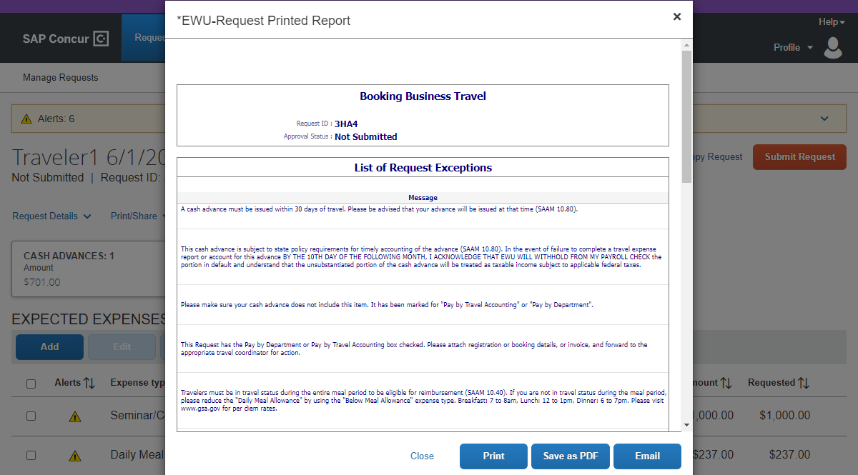

To submit your request report
- On the request report page, click Submit Report.
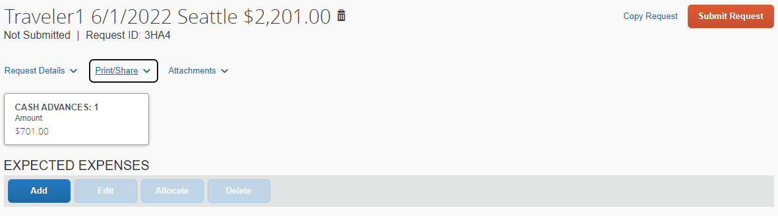
A Certification window appears, which requires you to attest that the request complies with EWU policy, and that if cash advance funds are not returned in a reasonable amount of time, the remaining funds will be reported and taxed as income.
- Review the statement and then click Accept & Continue.
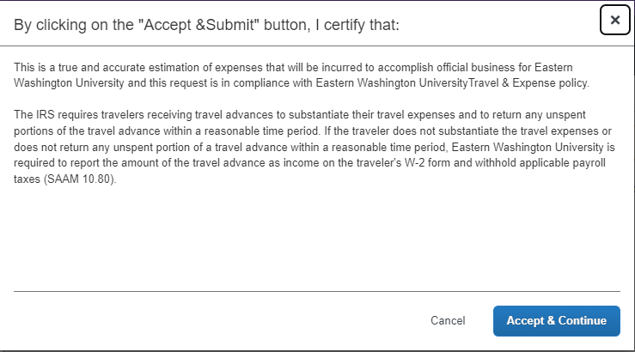
Your request is submitted and waiting for approval.
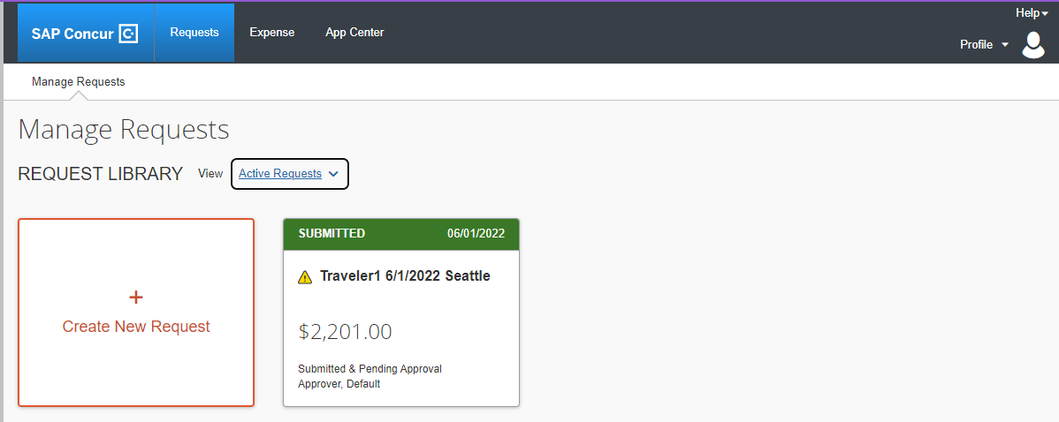

Approving Requests
As a request approver you can review and approve a travel request before an employee incurs travel expenses.
To approve a request
- From the SAP Concur home page, on the Quick Task bar, click Required Approvals.
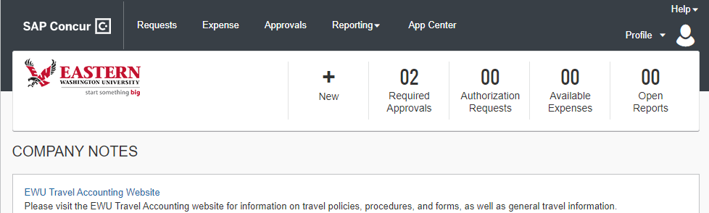
- On the Requests tab, click the request name that you want to review.
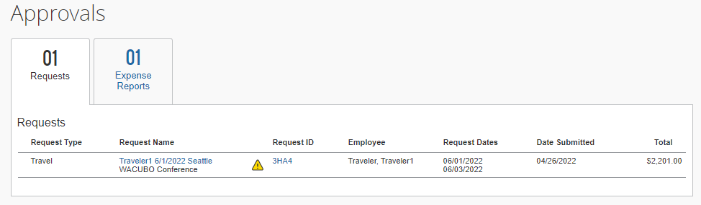
As an approver you review the details of the expected expenses and any attached documents before you approve the request.
- Click the Request Details dropdown menu to review the Request Header and Timeline, Audit Trail, and Allocation Summary details.
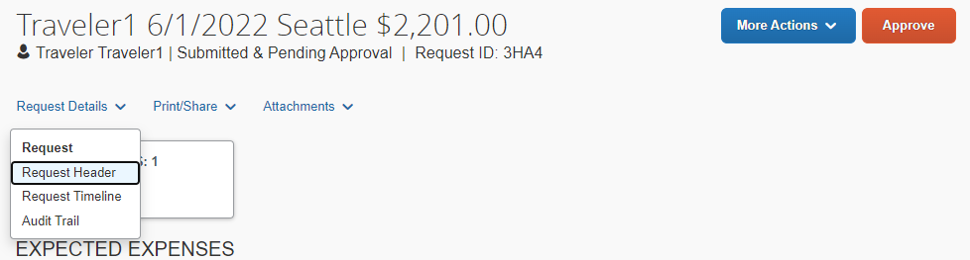

You can view existing Comments on the request and add additional comments as needed. If you made any changes, click Save.
If documents are attached to this request, an icon is displayed next to the Attachments menu.
- To view the attachment, click the Attachments dropdown menu, and then click View Documents.
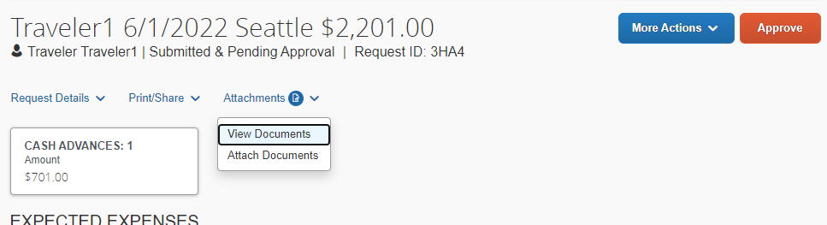
- After you are finished viewing the documents, close the window.
- Review the remaining request details and click Approve.
To send a request back to a user
In the following example, you will see how to send the request back to the employee.
- Click the More Actions dropdown menu, and then select Send Back to Employee.
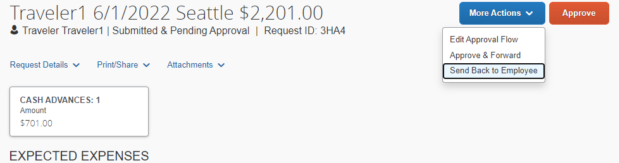
When sending a request back to an employee, you are required to enter a comment, which explains the reason for returning the request.
- In the Send Back to Employee window, enter the Comment, and then click Send Back.
To add an additional approver
As an approver, you can add additional review steps for a request. For example, you might need to forward the report to additional approvers if the request contains allocations to an index that is not within your approval authorization.

- Click the More Actions dropdown menu, and then select Edit Approval Flow.
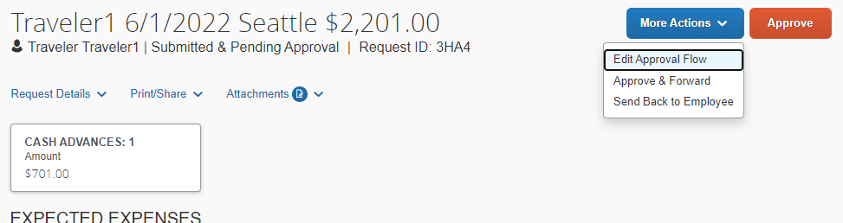
- In the Edit Approval Flow window, click Add Step to add an additional approval step for this request.
- In the User-Added Approver field, search for and select the approver that you want to add to the workflow.
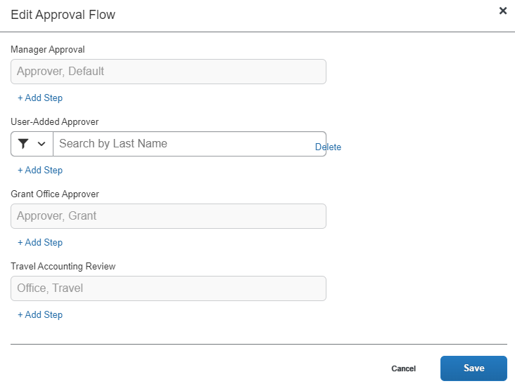
You can add additional approval steps as needed.
- When you are done adding your approval steps, click Save.
- Click Approve.
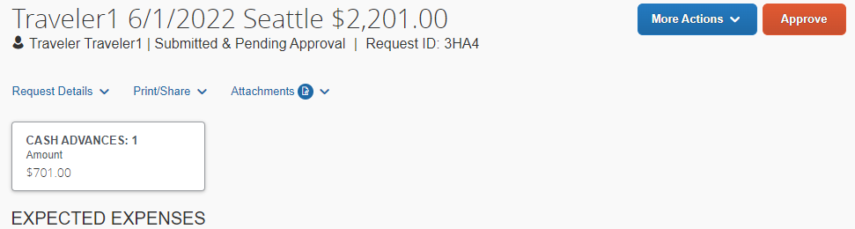

Adding a Request to an Expense Report
You can add an approved request and its expected expenses to a new expense report.
To add a request to an expense report
- From the SAP Concur home page, click the Requests menu.
- Click the request that you want to create your expense report from.
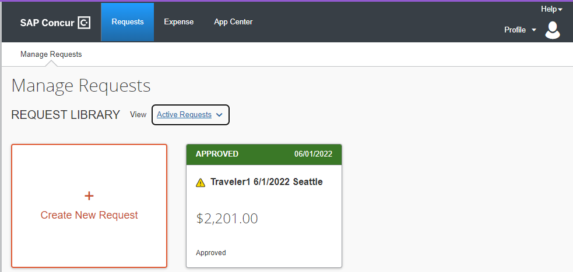
- To create the expense report with the attached request, click Create Expense Report.
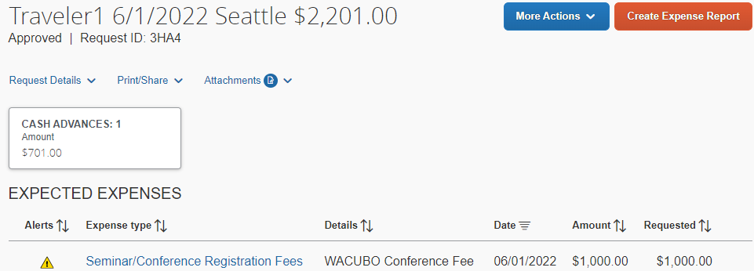

The expense report automatically opens to the expense report page and you can see that the request and any related cash advance is attached.
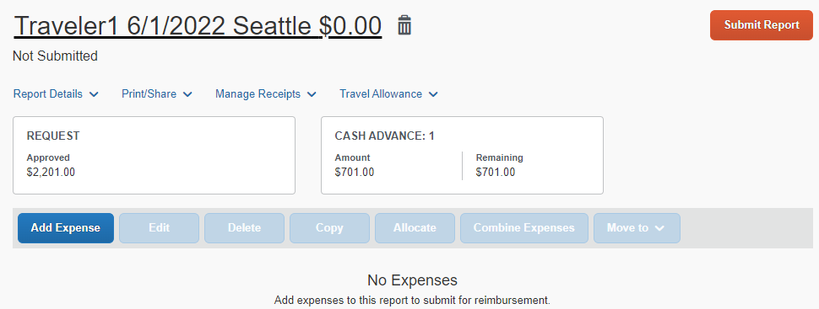
The expense report header is automatically updated based on the request.
If you need to claim travel allowances, you must update the report header to create a travel itinerary.
- On the expense report page, click Report Details and click Report Header.
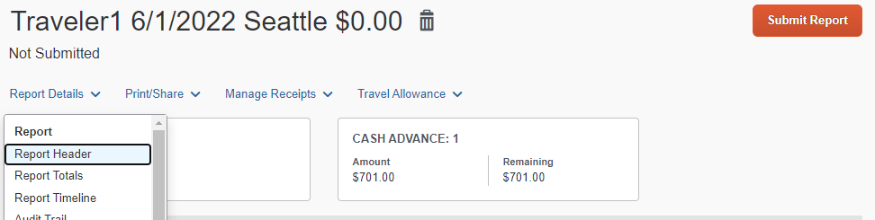
- Scroll to the bottom of the report header and click the Yes, I want to claim Travel Allowance radio button and click Next.
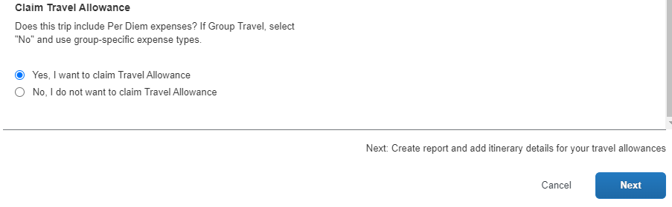
You must add your expenses manually to the expense report. Refer to the SAP Concur Expense Quick Guide for detailed steps to add an itinerary and complete your expense report.

Closing a Request
After you submit all your expenses related to a request, you can close the request. After you close a request, you can no longer associate it with an expense report.
NOTE: If you close a request that is associated with an unsubmitted expense report, the request is disassociated from the expense report. The authorized amounts are removed, and the request balance is reduced to zero.
- From the SAP Concur home page, click Requests on the menu bar.
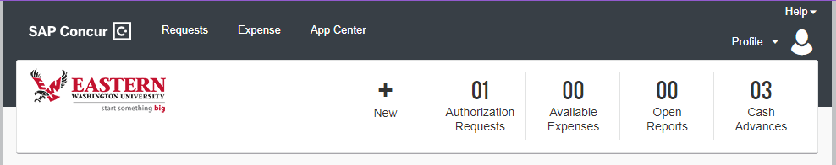
You can close/inactivate a request after it has been approved and the related expenses have been added to a report.
- Click the View dropdown menu, and then select Approved.
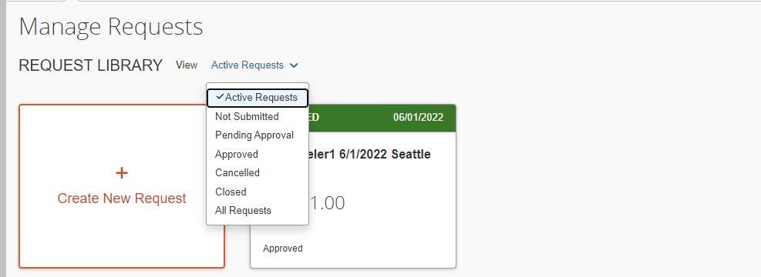
- Click the Request that you want to close.
- Click the More Actions dropdown menu, and then click Close Request.
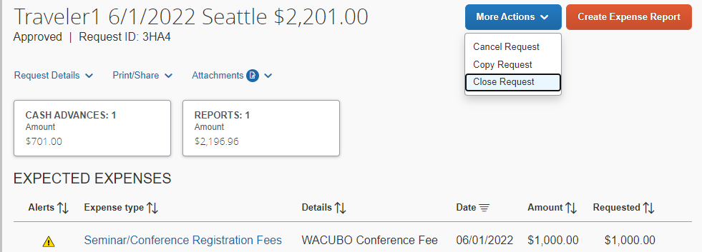
- To view closed requests, on the Manage Requests page, click the View dropdown menu, and then select Closed. Note that you cannot attach a closed request to an expense report.

