**Goal**: Devise some specific ways of talking about the cognitive demand of a task, and connect it to the purpose of students doing a task. Include the idea that tasks can provide opportunities for meaningful mathematical discourse and productive struggle.

Individually, then discuss in your PLC: What do we mean when we talk about the ‘cognitive demand’ of a task? Jot down a few ideas you look for when looking at the cognitive demand of a task.

Sort tasks from lowest to highest cognitive demand, and while you discuss them, write down the characteristics you use to discuss the cognitive demand of a task.

Low cognitive demand:

High cognitive demand:

**Discussion of higher demand tasks**:

* In what ways do the tasks you identified as higher level support coherent and focused learning, helping students make connections between concepts and procedures?
* In what ways can the tasks provide opportunities for meaningful mathematical discourse? Specifically, what aspects of each higher-level task is ***problematic*** for students mathematically?
* What opportunities are there for students to engage in and reflect on their use of the SMP?

**Task A** (from Engage NY Algebra 1)

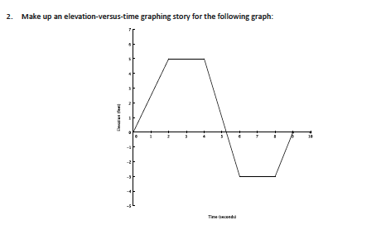

**Task B** (from Engage NY Algebra 1)

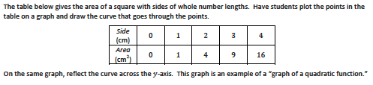

**Task C** (from Engage NY Algebra 1)

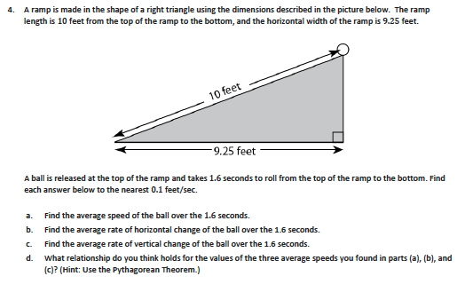

**Task D** (from Engage NY Algebra 1)

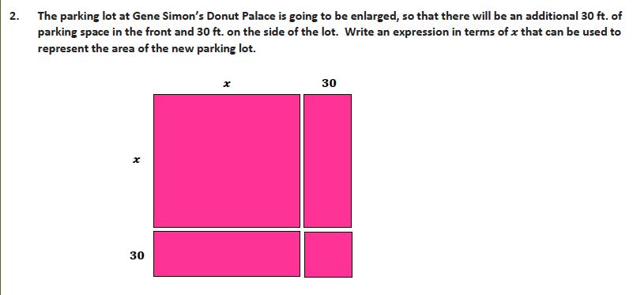

**Task E** (from Kuta Software – Infinite Algebra 1)

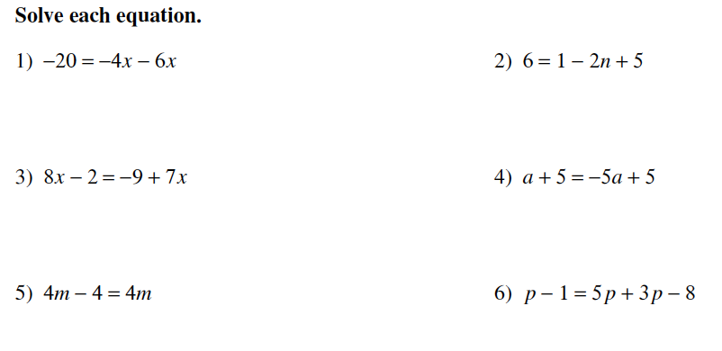

**Task F** (from Engage NY Algebra 1)

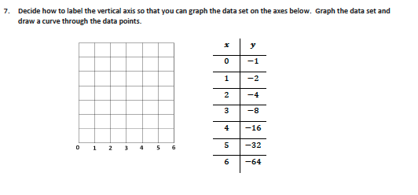

**Task G** (from Engage NY Algebra 1)

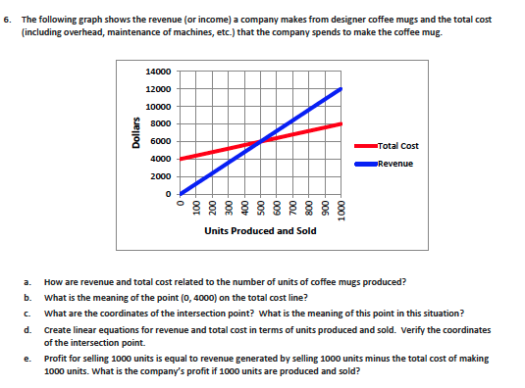

**Task H**

Solve the equation  for *x*.

**Task I**

Write four exponential expressions, one for each of the following criteria. All the expressions should simplify to .

* 1. Written as a product
  2. Written as a sum
  3. Written as a difference
  4. Written as a quotient

**Task J**

You study buddy was solving the following equation: . He first set each factor equal to 1, justifying that 1 times 1 is 1, then solved for x in each equation:  or , so  or . Is your study buddy right or wrong? Explain, using a mathematical justification.