Directions:
Use cardstock to create the cards on the last four pages and cut them apart.
Each person gets one card and finds values for A, B, and C on their card. Note the following constraints:
- Each set of A, B, and C includes exactly one negative number and two positive numbers. Since many of the expressions can be changed into the given form in more than one way, use that constraint to help you identify your group.
- Negatives are not always factored out, and the GCF is not always factored out.
- Try to imagine how to get from the original to the given form without writing steps.
After everyone has found their group:
- What properties did you use and how did you use them? (There might be some disagreements on how the Distributive property was used, and participants may not mention the Commutative or Associative Properties, so these should be brought up if they don’t mention them).
- Two cards in each group use the same idea, but opposite starting and ending forms, which are these?
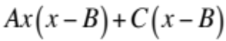 to 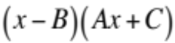 and
to
What is the sticking point for students in moving back and forth between these two forms?
How is the distributive property used?
Why is it important for them to understand this?
What are some ways to help them understand?

Here are the groupings:
Group 1: A=4, B=2, C=-3
Group 2: A=2, B=3, C=-4
Group 3: A=4, B=-2, C=3
Group 4: A=3, B=4, C=-2
Group 5: A=2, B=4, C=-3
Group 6: A=4, B=-3, C=2
Group 7: A=3, B=2, C=-4
Group 8: A=2, B=-3, C=4

Rewrite 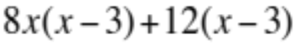  in this form: 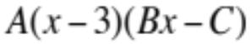  What are A, B, and C? | Rewrite 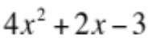  in this form: 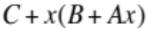  What are A, B, and C?
Rewrite 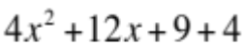  in this form: 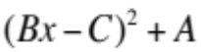  What are A, B, and C? | Rewrite 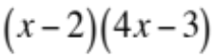  in this form: 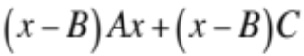  What are A, B, and C?
Rewrite 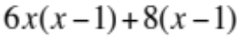  in this form: 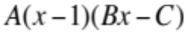  What are A, B, and C? | Rewrite 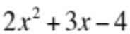  in this form:  What are A, B, and C?
Rewrite 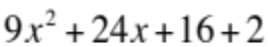  in this form:  What are A, B, and C? | Rewrite 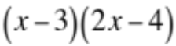  in this form:  What are A, B, and C?
Rewrite 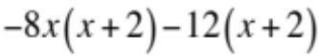  in this form: 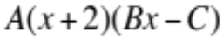  What are A, B, and C? | Rewrite 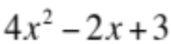  in this form:  What are A, B, and C?
Rewrite 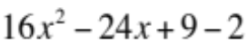  in this form: 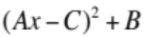  What are A, B, and C? | Rewrite 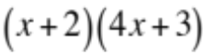  in this form:  What are A, B, and C?
Rewrite 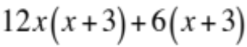  in this form: 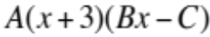  What are A, B, and C? | Rewrite 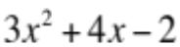  in this form:  What are A, B, and C?
Rewrite 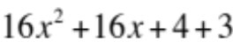  in this form:  What are A, B, and C? | Rewrite 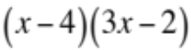  in this form:  What are A, B, and C?
Rewrite 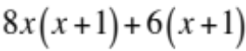  in this form: 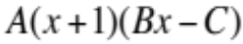  What are A, B, and C? | Rewrite 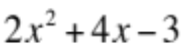  in this form:  What are A, B, and C?
Rewrite 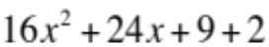  in this form:  What are A, B, and C? | Rewrite 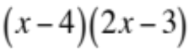  in this form:  What are A, B, and C?
Rewrite 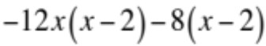  in this form: 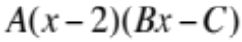  What are A, B, and C? | Rewrite 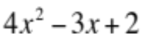  in this form:  What are A, B, and C?
Rewrite 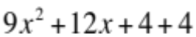  in this form:  What are A, B, and C? | Rewrite 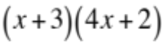  in this form:  What are A, B, and C?
Rewrite 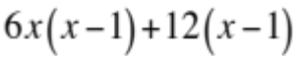  in this form:  What are A, B, and C? | Rewrite 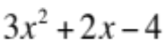  in this form:  What are A, B, and C?
Rewrite 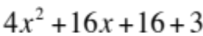  in this form:  What are A, B, and C? | Rewrite 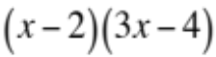  in this form:  What are A, B, and C?
Rewrite 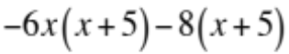  in this form: 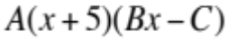  What are A, B, and C? | Rewrite 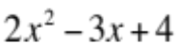  in this form:  What are A, B, and C?
  Rewrite 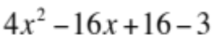  in this form:  What are A, B, and C? | Rewrite 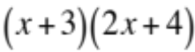  in this form:  What are A, B, and C?
  Rewrite  in this form:  What are A, B, and C? | Rewrite  in this form:  What are A, B, and C?

