Task Purpose: Use multiple representations to understand the rate of change of a quadratic function, using SMP 2 (reason abstractly) and SMP 3 (construct viable arguments and critique the reasoning of others).

Intersections
A line with slope 5 passes through the vertex of this parabola. Does it intersect the parabola in another point (other than the vertex)? If so, find the point of intersection. If not, explain why.

Stacey and Mike sit next to each other, so the I put their papers near each other so that both could be a part of the conversation.
Stacey’s work:
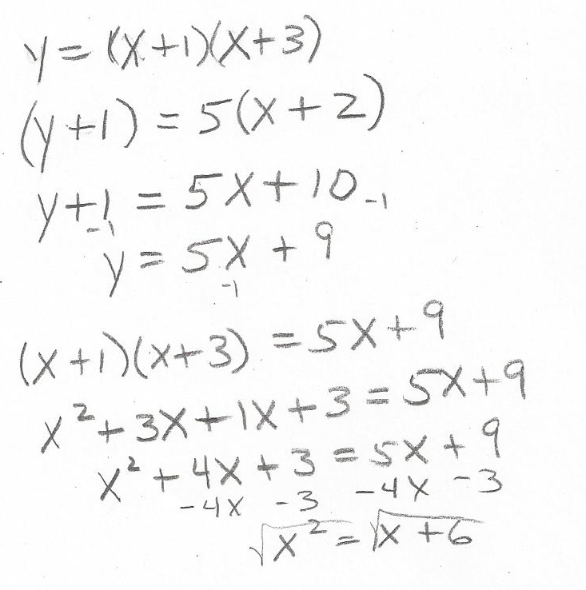

T: Stacey, can you explain how you found your equations?

S: I found the equation of the parabola using the x-intercepts, so it’s y=(x+3)(x+1). I found the equation of the line using the point slope formula. So, my equation is (y+1)=5(x+1). I set them equal and tried to solve it, but I got stuck after I wrote x²=x+6, so I made a table.

T: Can you explain how you found the intersection?

Stacey’s table:
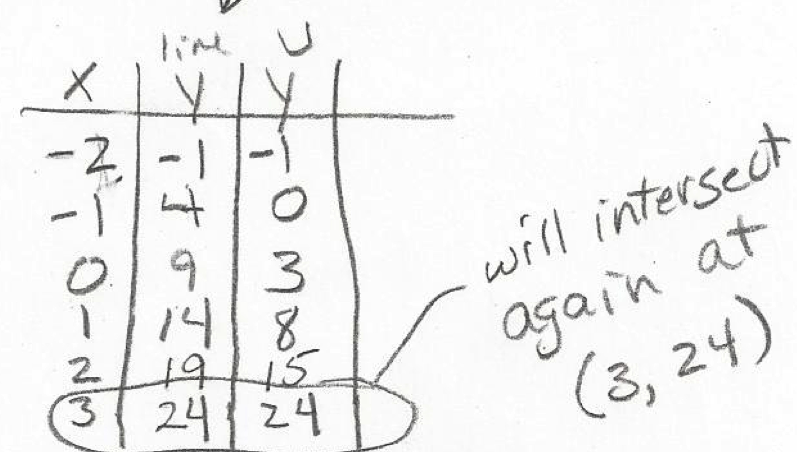

S: Yes, I used x-values starting at -2, and went up by 1. Those are the y-values of the line and the parabola [pointing]. I looked for when they are the same.

T: Thank you, Stacey. Mike, please explain your solution.

Mike’s answer:
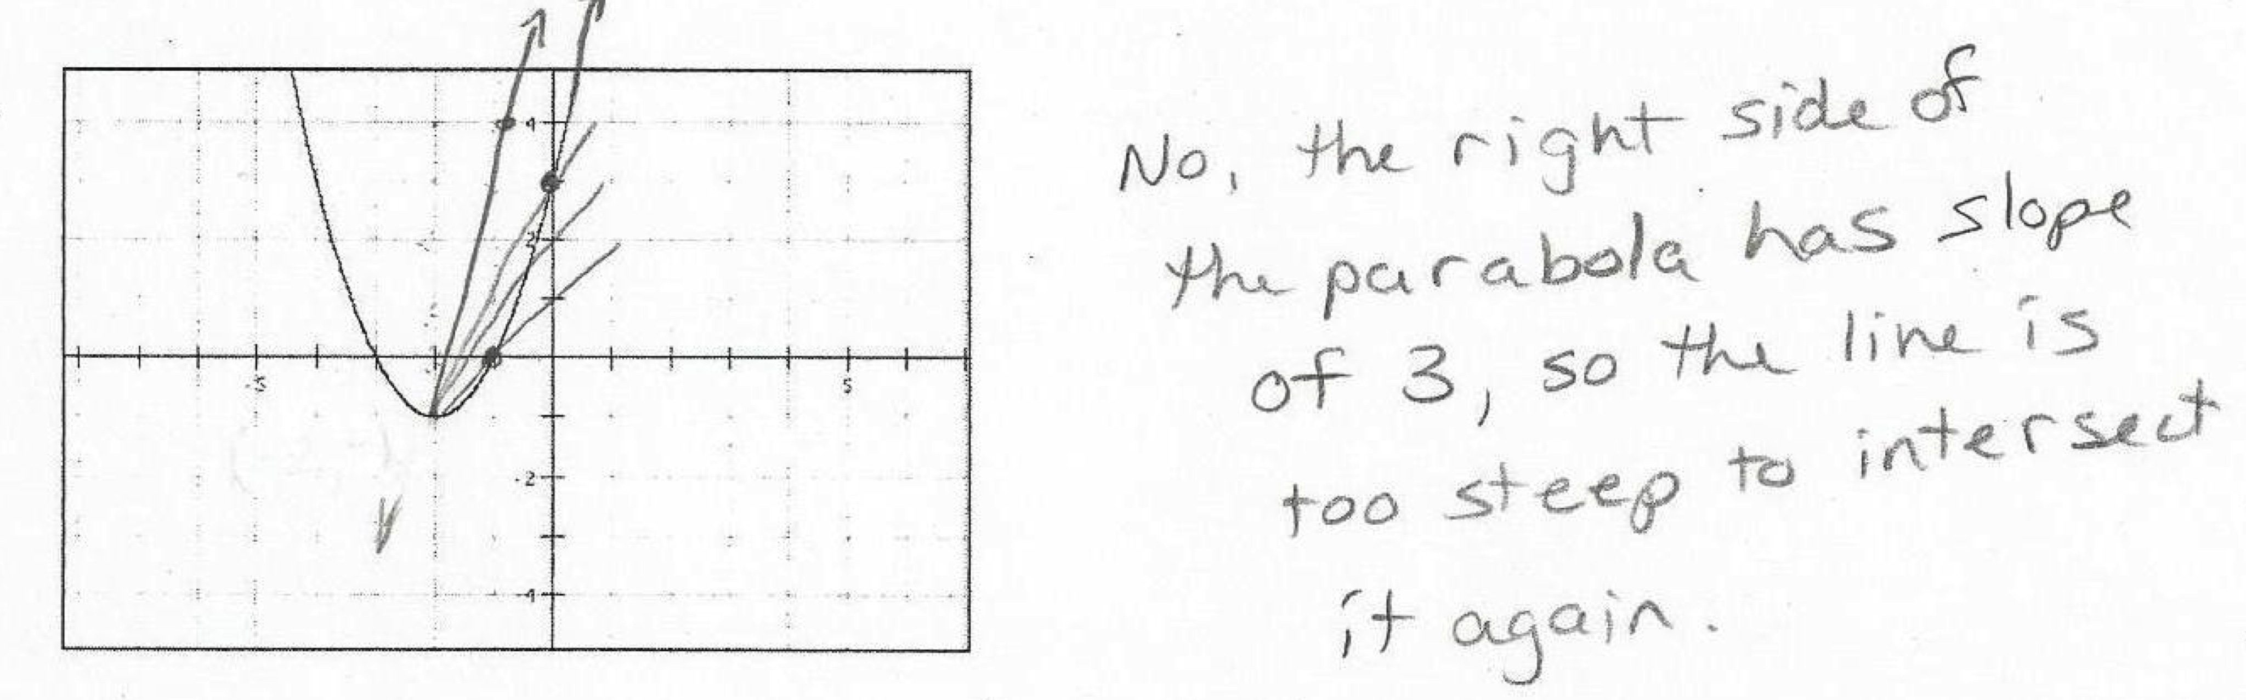

M: I drew lines with different slopes to find intersections of the two graphs. When the slope is 5, the line becomes too steep to cross the parabola.

T: Mike and Stacey, you have different answers and from your work, I see three different ways to look at this problem: with a graph, a table, and equations. Work together to discuss your different ideas and come to a consensus about the answer to this question. I’ll be back in a couple of minutes to check on you.

(A few minutes later)
T: Explain to me what you decided.

M: We graphed them on larger graph paper and saw that the parabola keeps getting steeper, and Stacey was right, there is an intersection at (3, 24).

