Vignette A
Mr. Bosley had the following warm-up on the document camera as students arrived to class one day:
The value of s is eight more than the value of t. Write this information in mathematical symbols.
After you write your answer, rate yourself from 0-5 on how confident you are that your answer is correct. A 0 means you have no confidence, and think your answer is probably wrong. A 5 means that you know you are correct and you can explain why your answer makes sense.

After giving them a minute to work, he walked down the first row and saw the following answers on his students’ papers:
1
5
4
5
5
5
2

Back at the front of the class, he asked all students to read the statement again carefully, and write an example of values for s and t that would make the statement true. After a couple of minutes, he asked them to share their examples with their elbow partners and determine if their neighbor had a good example, and if not why not. Then, they were to work together to come up with two more examples, and one of their examples should be one that they think no one else in the room would come up with. Finally, he had them determine if their examples satisfied the mathematical statements they came up with originally, and if not, to revise their mathematical statements and their confidence levels.

Vignette A Questions:
- Determine if formative assessment occurred in this vignette and, if it occurred, explain whether or not it encouraged focus and/or coherence.
- What mathematical ideas are important in this task?
- How would you get students to think about these ideas?
- Choose two of the wrong answers and identify what students could be thinking. Discuss what you would say to or ask those students to help them think about the important mathematical ideas. In what ways do your questions/statements help the students make sense of the situation?
- What opportunities for SMP did Mr. Bosley provide and how did he set up these opportunities? Describe how he could support improved use of the SMP for student learning.
- What could Mr. Bosley do next to help students learn the critical mathematical ideas with understanding (focus and coherence)?

Vignette B

Mrs. Garfield’s class was working on the following problem:

An international traveller consumed a 60 mg quinine tablet to prevent malaria. Each day, the traveller’s liver eliminated 75% of what was left of the quinine in her body.
- Fill in the table to show how much quinine was left in the traveller’s body each day.
Day | Quinine remaining
0 | 60
1
2
3
4

- Write a function that models the amount of quinine in the body t days after the traveller took the tablet.

When she walked around the room, most students had the correct values in the table, but many had chosen two points from the table and written a linear function to model the situation. She paused the class to get everyone’s attention and asked: “What kind of model should this be?” Jimmy answered: “Exponential.” Mrs. Garfield responded: “Right, exponential. Everyone make sure that you are writing an exponential function for this situation. Look in your notes if you do not remember the form of an exponential function.”

Vignette B Questions:
- Determine if formative assessment occurred in this vignette and, if it occurred, explain whether or not it encouraged focus and/or coherence.
- What mathematical ideas are important in this task?
- How would you get students to think about these ideas?
- What opportunities for SMP are provided by the task?
- Revise the vignette so that Mrs. Garfield responds in a way that supports sense-making and a deepened understanding for all students.

Vignette C

Ms. Estes started class with a warm-up:

Graph the system of equations:

As she walked around the room, she notices that most students are graphing the two lines correctly, using the slope and y-intercept. She stops to ask Andy some questions:

Ms. Estes: You have something on your graph circled; what is going on there? Does anyone have graphs that are similar to these? (she puts Andy’s paper on the document camera)
Several other students: Yes
Ms. Estes: There is a point circled on your graphs. Why do we want to circle the point?
Andy: Because that’s the one they have in common.
Ms. Estes (to class): That is the point that they have in common. What do we call this point?
Several students: solution
Ms. Estes: the solution, absolutely right, that is the solution of this system of equations.

Vignette C Questions:
- Determine if formative assessment occurred in this vignette and, if it occurred, explain whether or not it encouraged focus and/or coherence.
- What mathematical ideas are important in this task?
- How would you get students to think about these ideas?
- What opportunities for SMP are provided by the task?
- Ms. Estes had a goal of improving students’ ability to reason abstractly and critique the reasoning of others when teaching this lesson. Describe ways she could do this.
- How could Ms. Estes reveal students’ understandings of the relationship between a point on a graph and solutions to equations?

Vignette D

Mr. Dearheart wanted his students to think about the meanings of variable expressions. He drew a very long real number line on the whiteboard at the front of the class, labeling only the point 0 near the middle. Then, he asked for volunteers; Brian and Jamil immediately jumped to volunteer although they didn’t know what they were volunteering for yet. Mr. Dearheart gave them each a small whiteboard to hold. Brian’s whiteboard had only x written on it, while Jamil’s had 2x written on it. He asked Brian to start at 0 and walk slowly in the positive direction along the number line, holding the whiteboard with x on the number line. He told Jamil that he should watch Brian and move along the number line accordingly. That is, where is 2x when x is where Brian is holding it? He told the rest of the class that they were to help Jamil, and then Mr. Dearheart moved to the back of the class.
As Brian moved in the positive direction, Jamil moved approximately twice as fast, staying to the right of him until he could go no further and Brian stopped.

Then Mr. Dearheart prompted Brian to go back to zero and slowly move left, in the negative direction, and again asked Jamil to move accordingly. Jamil stood in front of Brian at zero, then also moved left, but faster. Almost immediately, the class erupted:
Kenny: Wouldn’t 2x be positive if x is negative?
The question was directed at Jamil, and Mr. Dearheart was used to staying out of the way as students argued about their answers. Several other students spoke out to agree with Kenny, telling Jamil that he should be going in the positive direction.
Jan: Yeah, since x is negative and two negatives make a positive.
Mike: I agree with Jan and Kenny, like, x and x have the same sign, so its gotta be positive.
Amber: But two x means 2 times x, and 2 is positive while x is negative, so the answer is negative.
A couple of students talked with their neighbors, and Mr. Dearheart heard several students say, “0h, yeah,” and “I get it” so let it go at that.
Then he asked for two new volunteers, leaving x on one whiteboard and replacing 2x with x² on the other.

Vignette D Questions:
- Determine if formative assessment occurred in this vignette and, if it occurred, explain whether or not it encouraged focus and/or coherence.
- What mathematical ideas are important in this task?
- How would you get students to think about these ideas?
- How would you characterize Jan’s conception of 2x? What would you do to help her gain a better understanding of expressions like 2x?
- What opportunities for SMP did Mr. Dearheart provide to his students and how did he set up those opportunities? Describe how he could support improved use of the SMP for student learning?
- What could Mr. Dearheart say/do in the near future to have his class think again about the meanings of 2x and x²?

Vignette E

Mr. Brady put the following question on a quiz to find out what his students know about domain:

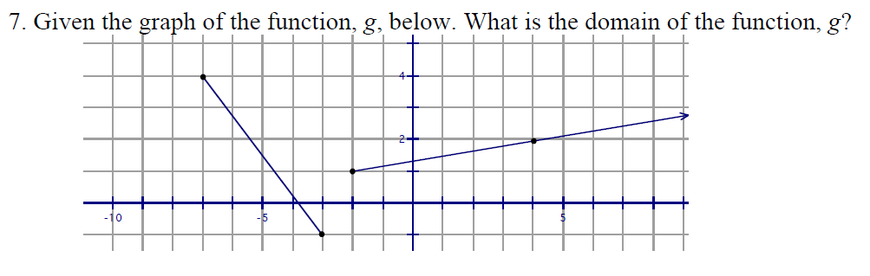

As he graded the quizzes, the following two examples were typical answers from his students:

A
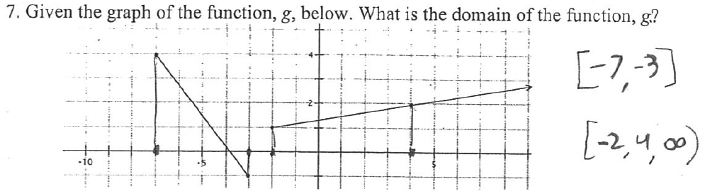

B
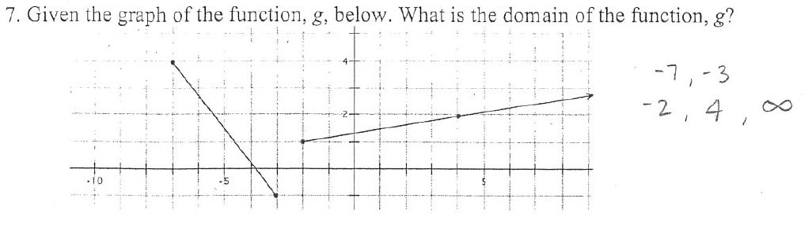

He was really surprised about the inclusion of 4 since he only inadvertently left the point (-2, 4) on the graph as he used Geometers’ Sketchpad to create it.
He would write a new quiz that did not have an extra (distracting) point on it and let his kids have another chance to take the quiz.

Vignette E Questions:
- Determine if formative assessment occurred in this vignette and, if it occurred, explain whether or not it encouraged focus and/or coherence.
- What mathematical ideas are important in this task? How would you get students to think about these ideas?
- How would you get students to think about these ideas?
- What opportunities for SMP are provided by the task?
- What could Mr. Brady do in the near future to find out what his students understand and don’t understand about the domain of a piecewise function when given the function graphically?

