AQUATICS FACILITIES

1. Basement: Main Fisheries Room with 8 large tanks and Tank Rack System
- Departmental Resource (maintained by M. Satterwhite)

Lighting and Photoperiod System:
There are two sets of lights in the basement, one that is manually turned on and off and one that is operated by a photoperiod control box. These can be set to turn on and off at any point in time. It is important to leave the manual lights off unless needed when the photoperiod system is set to “off”. Thus, you should always turn the manual lights off (clearly marked at the bottom of the stairs) when you leave the room, even if you do not remember turning them on. There is also a bank of lights over the stairwell for safety. These should remain on while accessing the basement and turned off whenever leaving otherwise they will diminish the “night” effect when the photoperiod system is off. The photoperiod system should only be manipulated by faculty and staff.

Circulating Tanks (8):

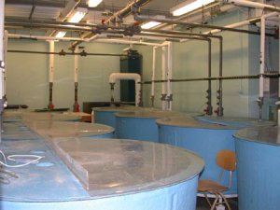

- Tank Configuration:

There are two sets of four tanks; each set of four is plumbed nearly identically. Each set is associated with it’s own well (2 total) where return water from four tanks empties to during the filtration process and is then returned to the tanks. Each set of four tanks thus “shares” the same water supply.

Each individual tank: 300-gallon circular flow-through holding tanks (150 cm diameter and 76 cm deep)

- Pumps & Flow Regulation

Each tank is a circular tank where incoming water flow can be positioned to create a circular flow or no flow. Each tank has an inlet and an outlet, each controlled by a valve that is taken from and returned to the well. If input is greater than output, the overflow is directed through the center tube which dumps to the EWU sewer system. This method of overflow can eliminate solids that build up in individual tanks. Additionally, there is an inlet to each tank for outside water that is intended to offset evaporation and should be set to a slow drip.

The well has a backup input that will fill the well with outside water in the event that excess water is dumped to the sewer system and well levels drop. The speed of this correction is limited and balancing the tanks correctly is critical and should only be performed by faculty or staff.

- Filtration:

There are two sets of filters that water is diverted through when returning to the tank. The first is a charcoal cylinder that primarily adsorbs ammonia and some other wastes. The second filters are pumice rocks that primarily trap particulates. Each needs to be maintained regularly depending on the amount of fish being held and at what temperature. Water is also returned through a “waterfall” that can provide denitrification of the water.

- Aeration:

A central air pump provides pressure to allow “bubbling” of tanks with room air. Each of the outlets should be left open, whether attached to an active bubbler or not, to prevent backpressure on the pump.

- Temperature Control

There are two separate chilling units for each set of four tanks. The “new” chiller (Aqualogic model MT-8, San Diego, CA) is completely enclosed downstairs and is very reliable. The “old” chiller requires an external evaporator and has difficulty maintaining cold temperatures during the summer periods when incoming water temperature is warmer and thus the “new” system should be used during these times if critical research is occurring. Each set of four tanks must be at the same temperature as water is shared between the four tanks.

- Dechlorination System

Two large dechlorination tanks are now in use full time after the campus water was chlorinated in 2009. The external water coming in is plumbed through these systems before entering the system. These are supposedly checked periodically by the Plumbing Group (primary contact: R. Heston) but if critical stocks of fish are being held, the responsible person should obtain a chlorination test kit to be absolutely sure it is functioning properly.

Tank Rack System (T. Hancock)

A Four Shelf Stand-Alone Flow-Through Fish Rack system (Aquanetics) is used in conjunction with the cooling system for the larger tanks (the “new” chiller). These are flow-through systems that are self cleaning. There are 12 2.8-Liter Tanks and 18 6.0-Liter Tanks. In the simplest configuration, these share the water from the “new” system of larger tanks and thus are subject to the same temperature regime in use there. This system is only to be used with the permission of T. Hancock.

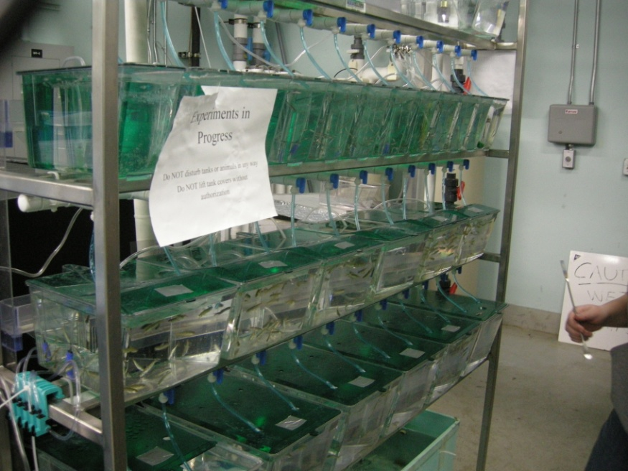

2. Basement: Supplemental lab/project room
- Common/Department Space (currently utilized by D. Cousins: advisor M. O’Connell)

3. First Floor: Fisheries Facilty
- Departmental Resource (maintained by M. Satterwhite)

Living Streams:

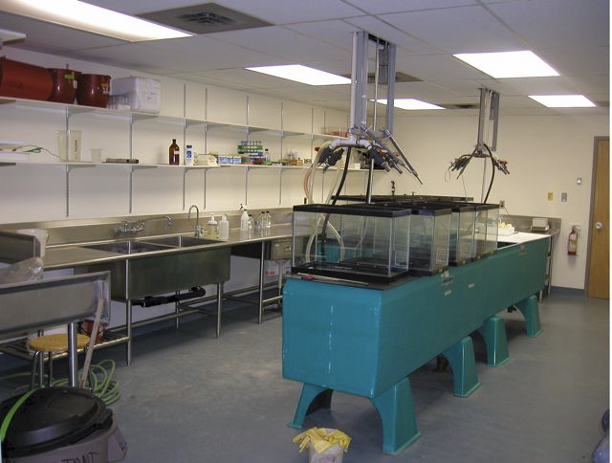

Up to eight 130 gallon Living Stream® aquarium equipped with charcoal filtration are utilized in this room. Many of these units have chilling units capable of temperatures as low as 5 degrees C. All usage of this room should be requested through Dr. Al Scholz.

Tank Rack System (T. Hancock)

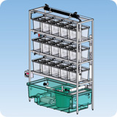

A Four Shelf Stand-Alone Flow-Through Amphibian/Fish Rack system (Aquanetics) is used in conjunction with a living stream for providing water. These are flow-through systems that are self cleaning. There are 10 16-Liter Clear Molded PETG Tanks and 8 30-Liter Clear Molded PETG TanksTanks. This system is only to be used with the permission of T. Hancock.

