This is an overview of the E-Tutoring platform, showing you how to log in, ask a tutor a question (eQuestion), and submit a draft of a writing assignment (Writing Lab), and how to enter a live chat with an available tutor.

**To you access the Online Tutoring Portal**

**from the PLUS website**

**https://inside.ewu.edu/plus/**

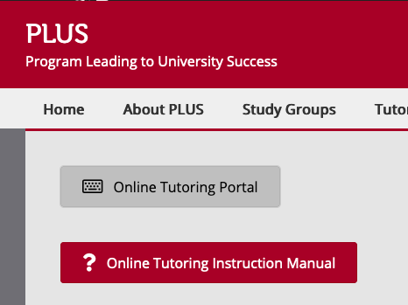

Enter your Username and Password.

Username is NetID

First-time users Password Instructions on Webpage

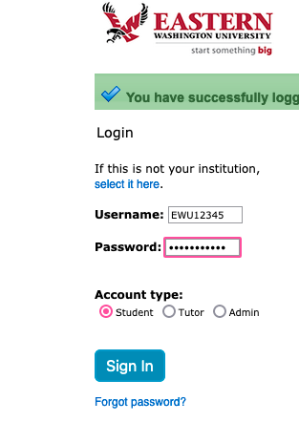

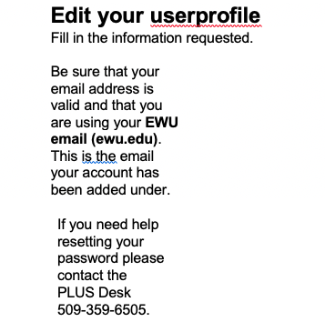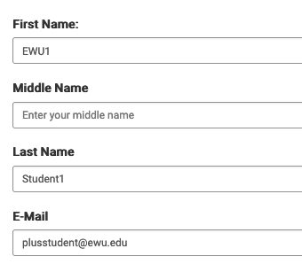

**Under Terms and Conditions:**

Check the I agree & Click Update Profile



