Banner
Online Requisition Handbook

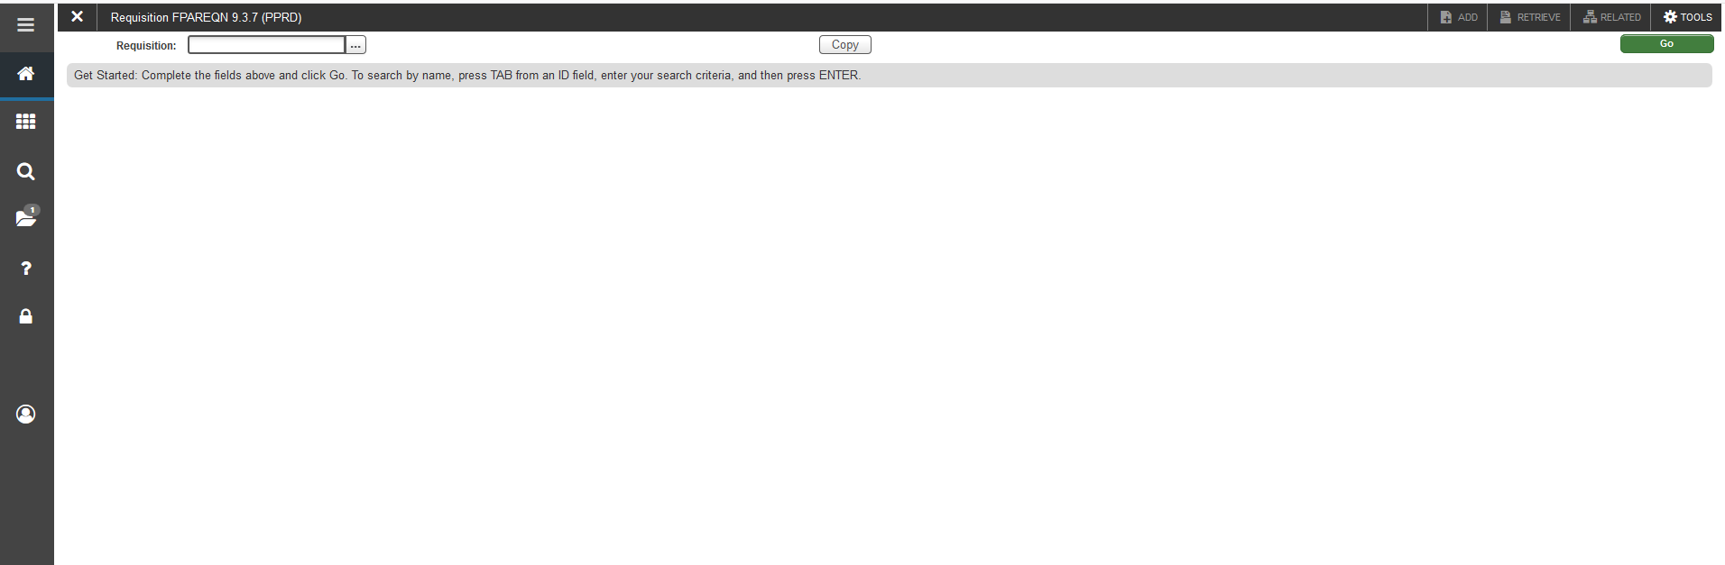
- Log in to Banner
- To enter purchase requisition: FPAREQN (enter)
- To view a purchase requisition: FPIREQN (enter)

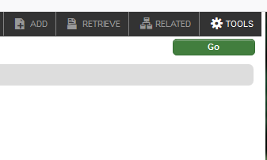
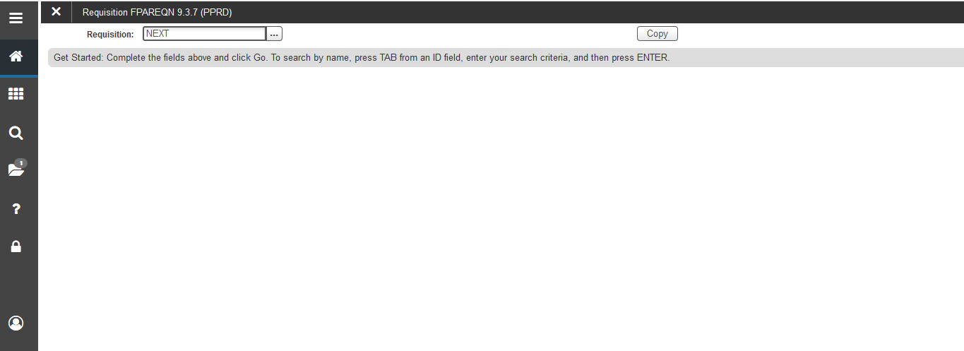

- You can either put “Next” in the requisition box, or you can leave it blank and then click Go
  - Do not put a number in this box unless you have previously started and not finished a purchase requisition. In that case, put in the exact requisition number (ie R0001234) and click next block to continue from where you left off

- If you are using FPIREQN to look up a requisition, put the requisition number in the box and click next block

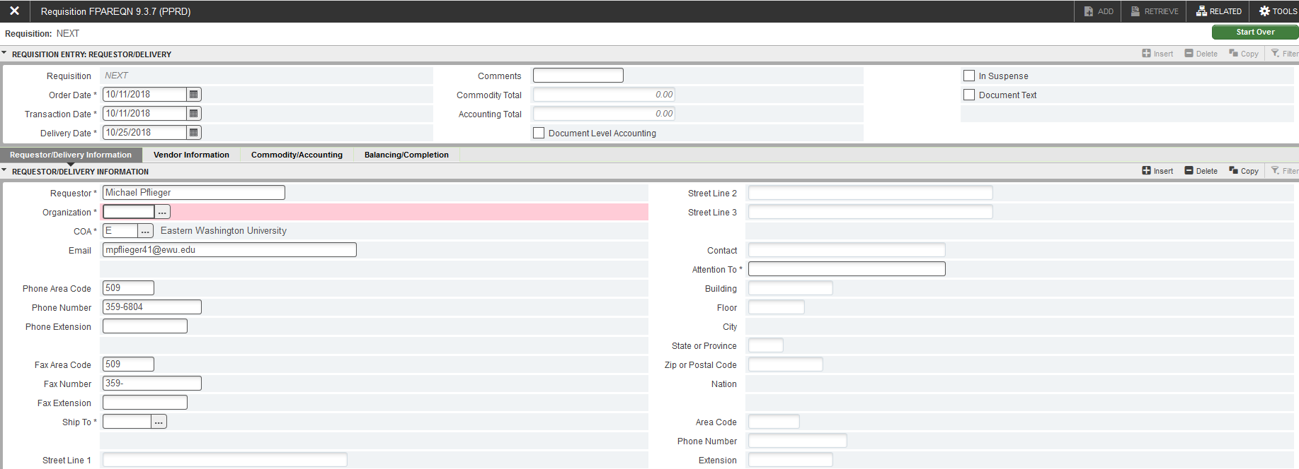

- Order date and transaction date will fill automatically with today’s date

- Delivery date is the date you expect the goods/services, or if you don’t know, usually we use 2 weeks out
- If you have only one item, or all items have the same account number, check the “Document Level Accounting” box on this screen. This will allow you to use only one FOAP later. If you have items with different account numbers, leave it blank.
  - Please make certain that all of your items are indeed the same account number before you use this option – we can’t change it on the purchase order
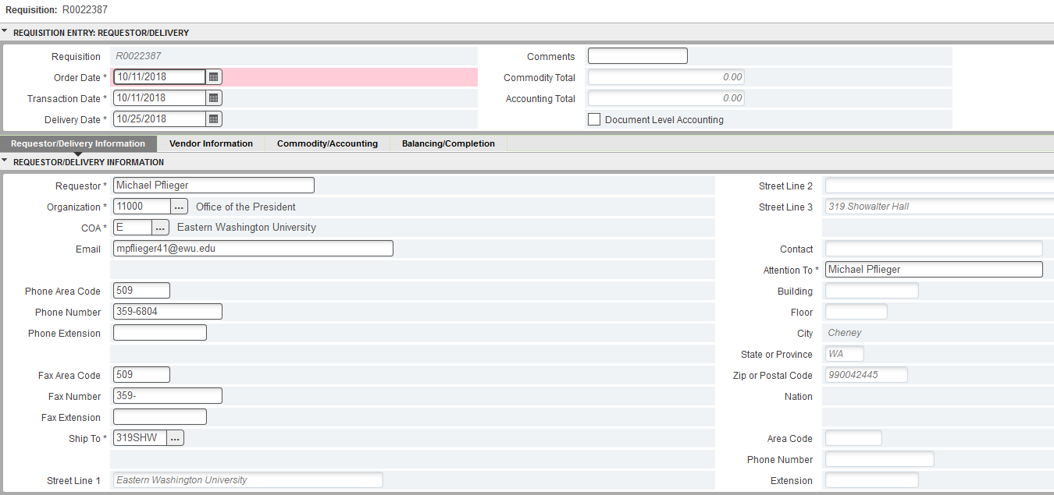
- Select the Organization from the Drop Down Menu or type it in
- Fill in the Ship to
- In Attention To fill in your name
- Then move to the next screen by selecting Vendor Information
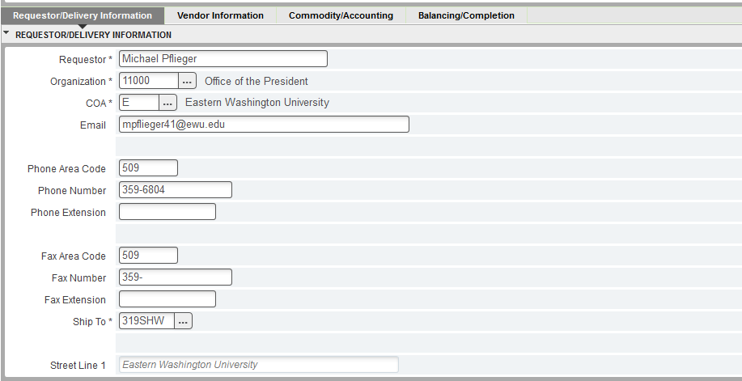

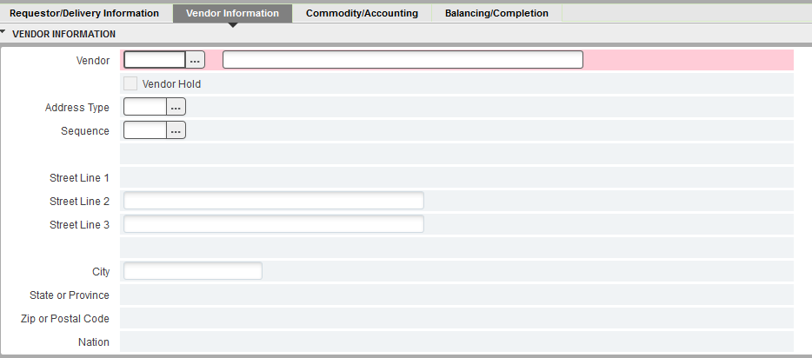
- If you know the vendor number, you can type it in the box
- If you do not, click the drop down dots … next to the vendor box
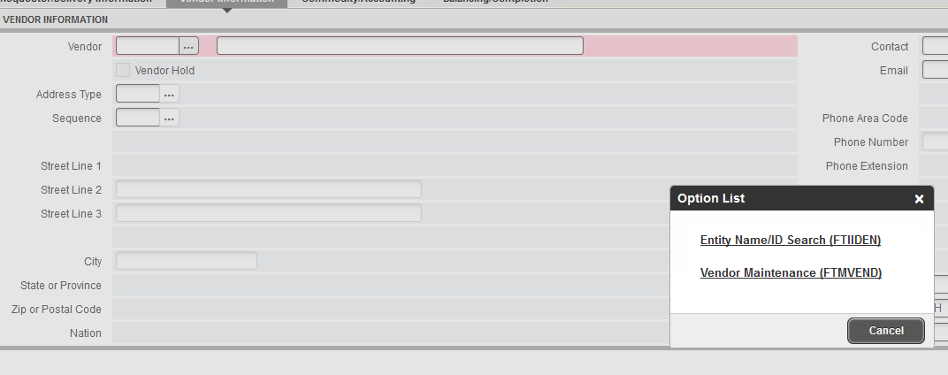
- Click on “Entity Name/ID Search”

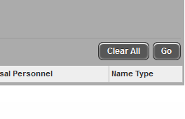
- To do a vendor search, start with a % sign, put in only what you know for sure in the Last Name Field will be there and follow with another % sign, then select Go
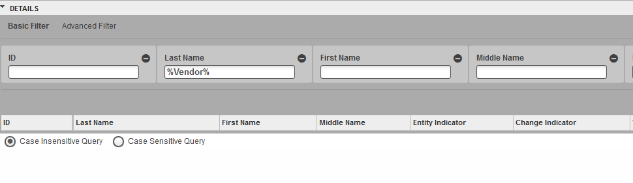

- For example: To search for Coeur d’Alene, put in %Coeur% and press Go. If you want to narrow it down so you don’t get as many responses, you can put in %Coeur%lene% and it will show only those vendors that contain that exact information
- If your vendor comes up in the search, double click on their vendor number and the vendor area will populate
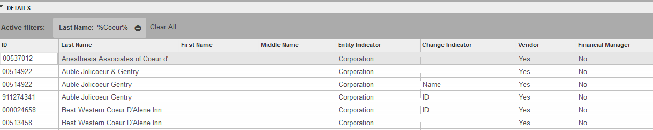
- If your vendor is not there, X out of the inquiry screen
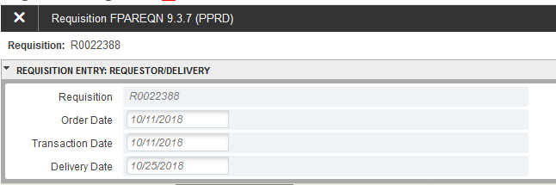

- If you can not find the vendor, you can leave the vendor field blank and move on the the Commodity/Accounting screen.
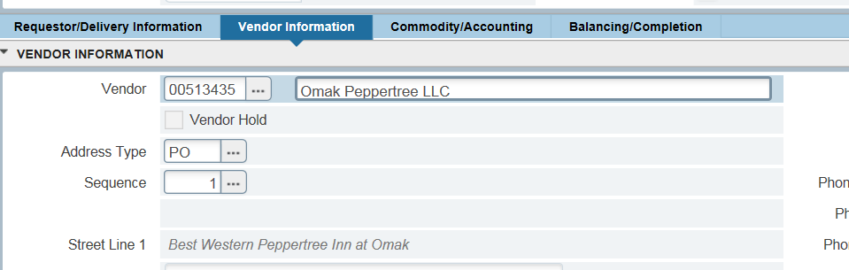

- Once you’re done, click the gray Commodity/Accounting
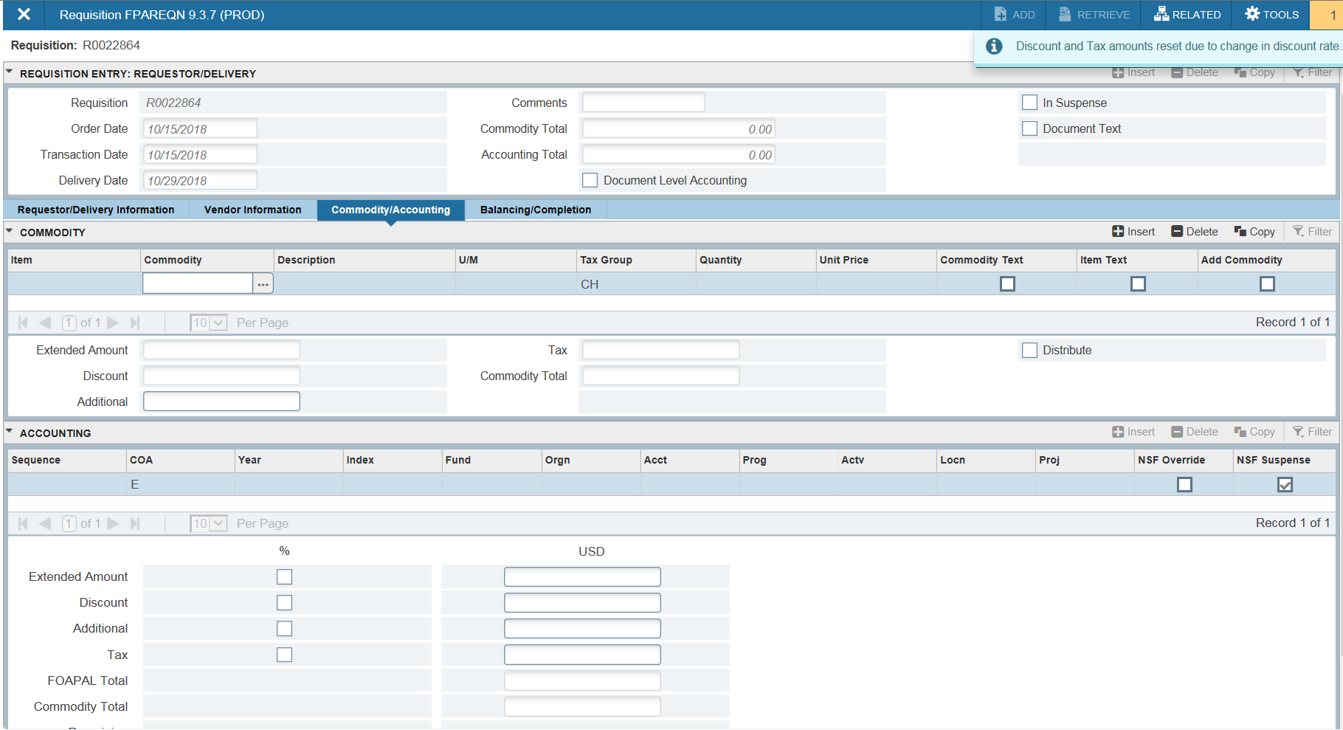

- Nothing ever goes in the “Commodity” box

- Click to Description and enter your first line item 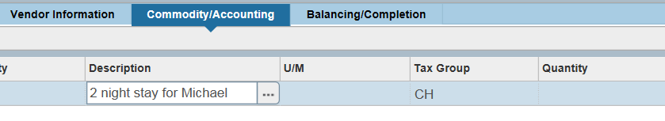

- Click to U/M (unit of measure) and enter EA (each) if there are multiple lines or items, or LOT if there is just one. LOT is used for all reimbursements.
- If you need to change the tax rate from the default CH (current Cheney tax rate), you can do a search with the drop down arrow or just type it into the box if you know it. “NT” is no tax
- Tab to quantity – enter quantity
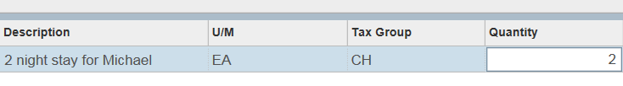
- Tab to Unit Price – enter unit price
- If you have more line items to add click on the insert arrow and you can repeat the process with your remaining line items
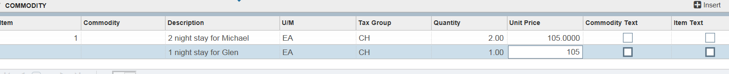
- IMPORTANT: If you clicked the “Document Level Accounting” box, you can enter all line items and then enter the FOAPAL information. If you did NOT check that box, you will need to next block down to the FOAPAL between each line item and click save after you enter the accounting information. Then previous block back to the commodities to enter your remaining line items

- Next go to the Accounting section and fill in your departments budget index
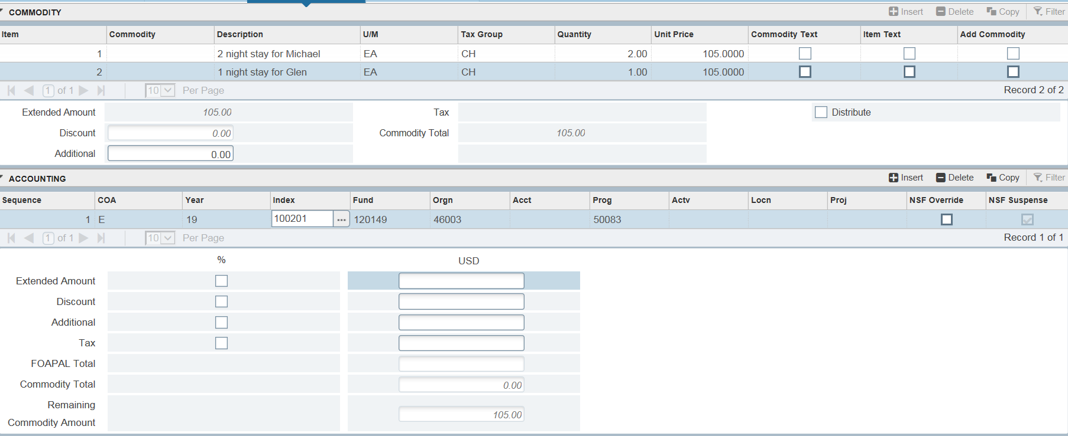
- Fill in the Account code box.
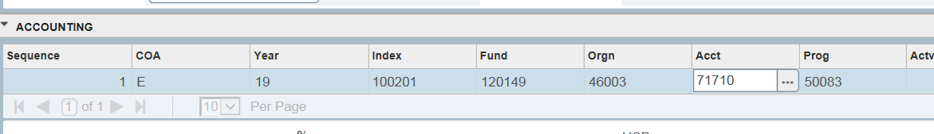

- When all of your information is entered, next block or click on the gray “Balancing/Completion”
- If everything looks correct, and all the Status reads Balanced, click “Complete” and note the requisition number
  - Be sure to write the requisition number on your backup documents
  - If you do not have backup documents (ie if you’re inputting a regular order) please print out any page of the online requisition and send it in with the requisition number on it. This way when we receive the paperwork, we know that it’s ready to go.
  - Please make sure that your requisitions are completed and approved before you send us your backup documents.
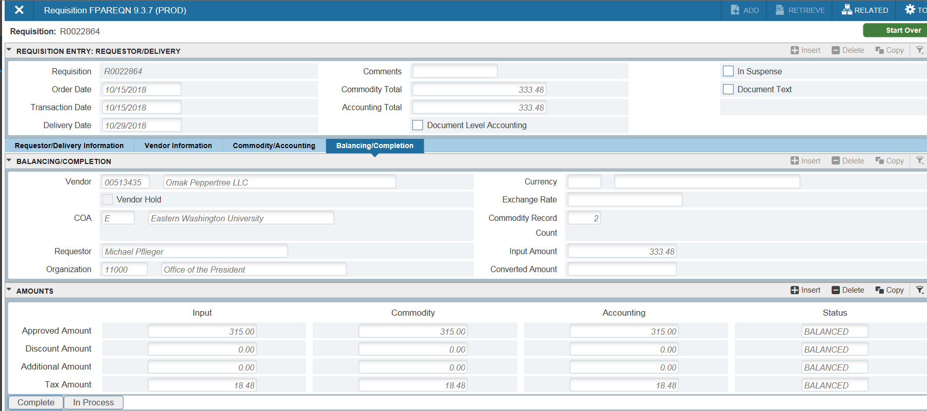
General Notes:
- Reimbursements – online requisition, invoice voucher and original receipts.
  - Also, be sure that you have proof of payment ie back of canceled check, bank statement (account numbers may be blacked out), receipt showing “paid by credit card” etc.
  - Make it only one line item, no matter how many items were purchased. The U/M will be “Lot”, the quantity will be “1”, the tax rate will be “NT” for no tax and then the full amount of the reimbursement, including the tax, will be the amount.

- Invoice payment -
  - If you are doing an online requisition to pay an invoice for an order already received, and the items are all the same account number – do it as “1 lot” for the entire amount. If you have an invoice with ten line items, for example, you do not need to enter ten line items. Enter one line item for the total amount.
  - If you have items that have different account numbers, use commodity level accounting and enter each line item, each with its own FOAPAL, to match the invoice.

