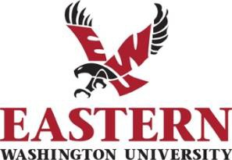

Sole Source Contract Award Notice

Publication Date: August 3, 2021

Procurement and Contracts at Eastern Washington University hereby publishes notice of the intent to issue a sole source contract. This notice is being given pursuant to the Revised Code of Washington (RCW) 39.26.140.

The university proposes to purchase products or contract services from Family Counseling Northwest, LLC – Molly Phillips, LLCSW for the following:

Provide Early Head Start professional infant mental health consultation services.

Family Counseling Northwest, LLC, Molly Phillips, LLCSW, is the only mental health provider with experience in providing mental health services to the Birth through 5 age range and/or who is willing to provide in-home services to Ferry, Stevens, or Pend Oreille county residents.

The Interim Chief Purchasing Officer of Procurement and Contracts has determined there is only one vendor qualified to provide this commodity or service.
Any vendor may file a challenge to this sole source award by contacting: Michelle Rasmussen, Interim CPO
Procurement and Contracts
Eastern Washington University O: (509) 359-6448
F: (509) 359-7984
mrasmussen2@ewu.edu

All challenges must be filed within ten (10) business days of this publication.

