0 7 . 1 1 . 2 0 2 3
1

Degree Works Planner - Editing Plans
Training Manual for Students

Prepared by
The Degree Completion Team

Introduction

The Degree Works Planner is an advising tool that students and advisors can use to map out a clear pathway for timely degree completion. Advising plans created in Degree Works Planner will show students the required courses within their program(s) and a recommended timeline of when they should be completed.

Accessing Degree Works Plans
You will need to ﬁrst access Degree Works

Click here to access Degree Works

- After logging into Degree Works, select Plans at the top of the Degree Works Dashboard and type your ID in the search box and hit enter
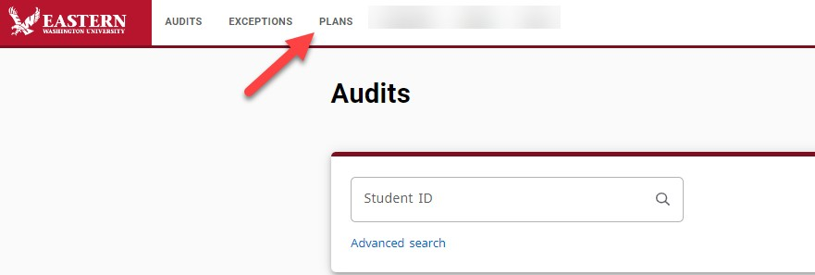
- In the Plan List block, you will see any plans that were previously created
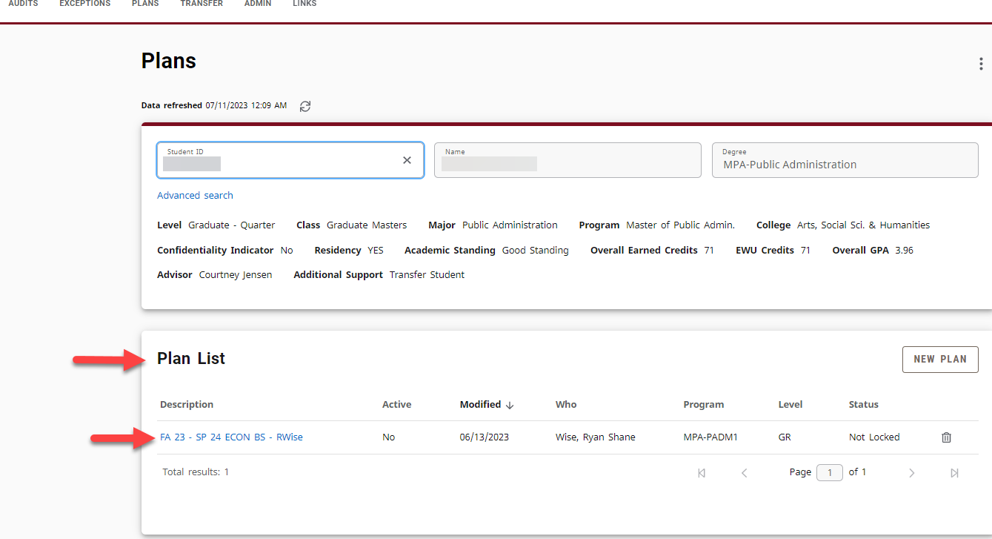

Editing a Plan allows you change or update your long- term plan. Some reasons for this could be: repeating a course, changing majors, adding a major, adding a minor.

- To edit a plan, you should find the plan that is Active and
Locked. Then click on the Title of the plan.

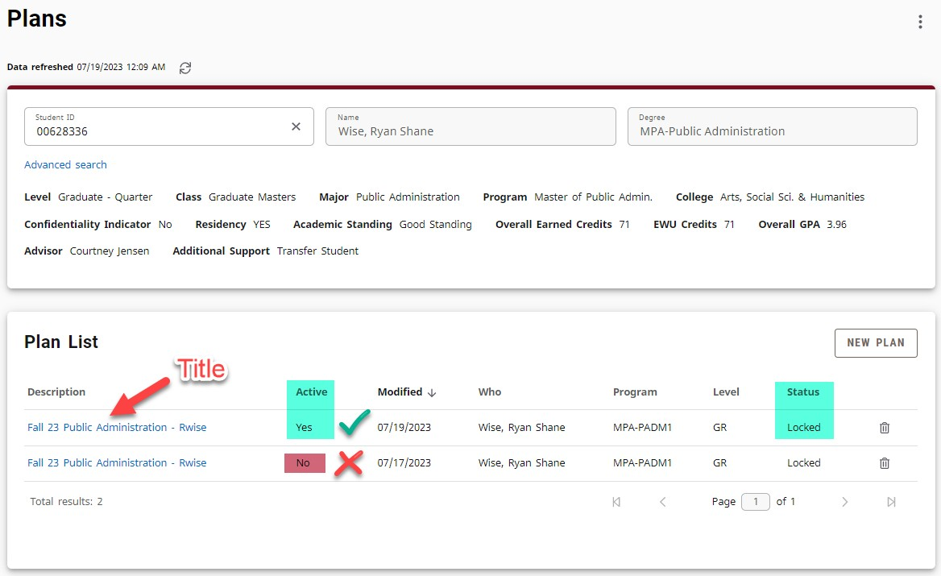

- Scroll down until you see the quarters/semesters. You can Drag and Drop a course from one term to another if you need to change a course's term.
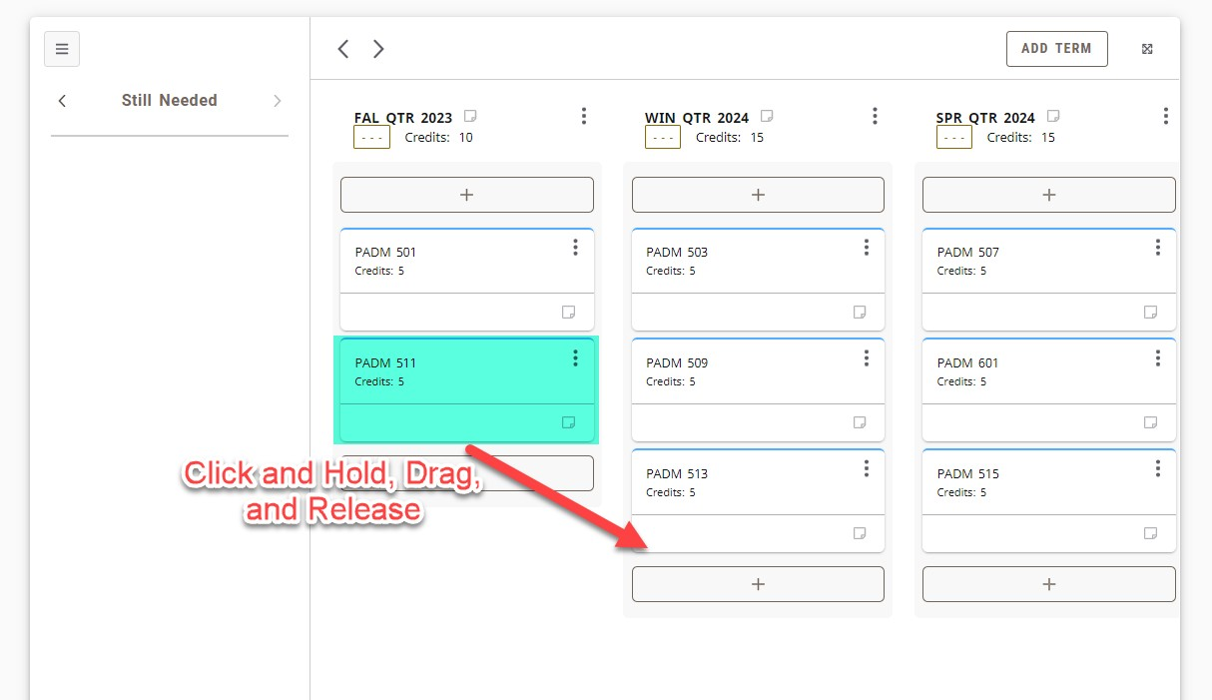
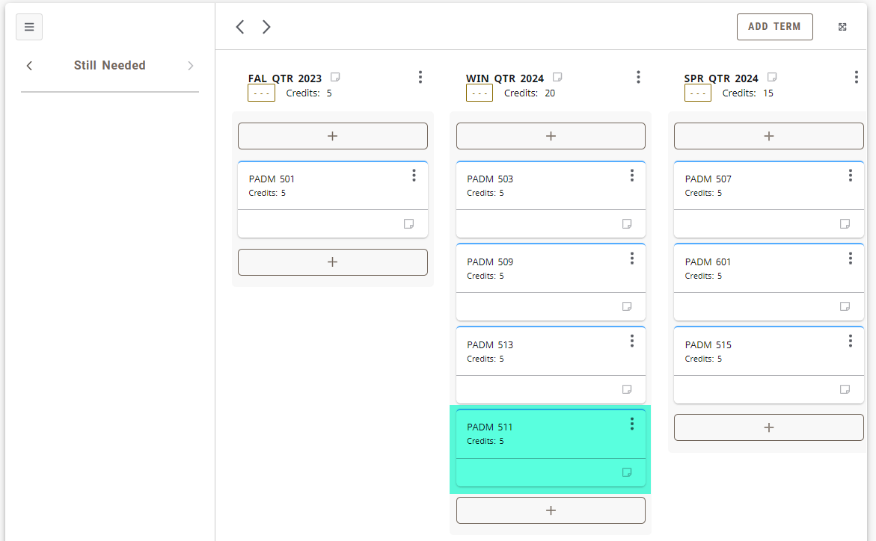

- You can search for a class that does not show up the Still Needed, you will need to do the search function. Click the arrow on the left hand side of Still Needed until you get to Courses.

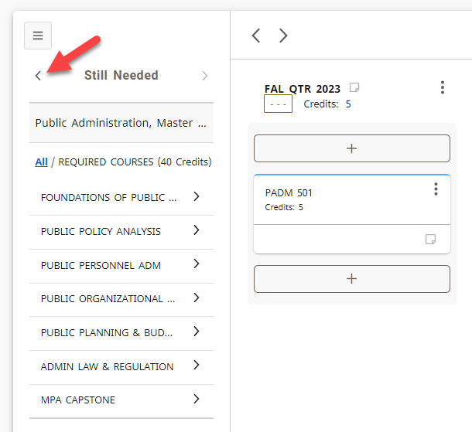
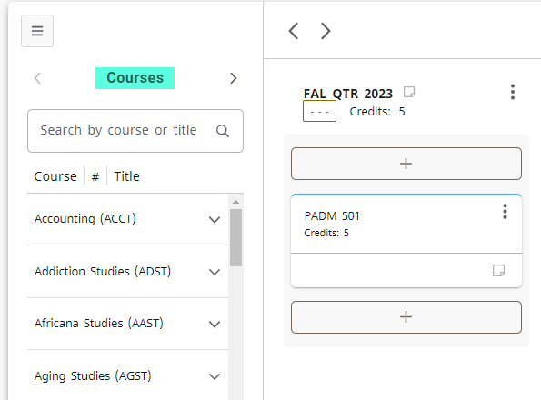
- Then you can type the subject into the search bar (don't use the number as it won't pull up the course). For example, I'll be using History to demonstrate this. I'll be looking for History 389.
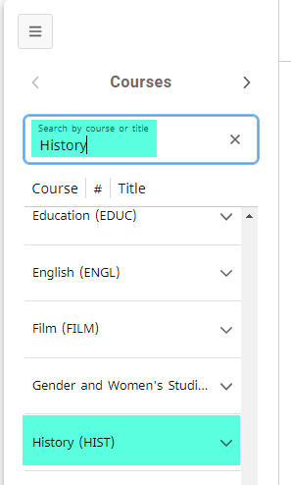

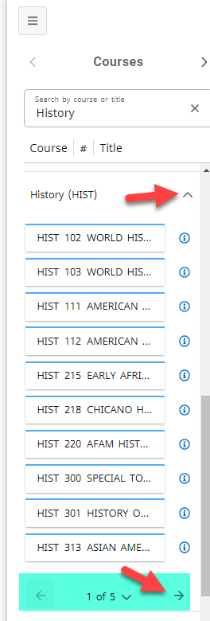
- You'll may need to scroll down to find the subject, but once you find it, click the arrow next to it. This will open up the subject with every available course from the catalog.

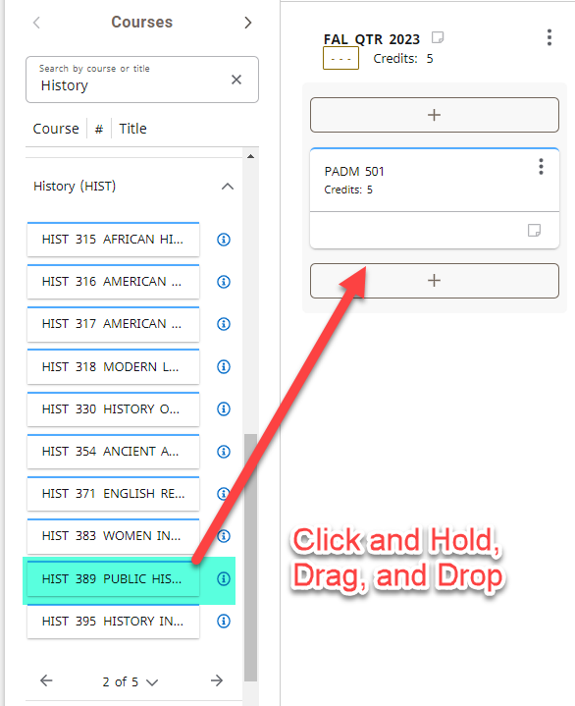
- The courses will go in an acending value. Click the arrow next to the pages to flip to the next set of courses until you find the one you are looking for.

- Once you have finished editing the Plan, you can just close the browser. This system works the same way as GoogleDocs and saves as you make changes.

