0 7 . 1 1 . 2 0 2 3
1

Registration- EagleNET

Training Manual for Students

Prepared by
The Degree Completion Team

Introduction

When your registration day arrives, you can easily register into your courses if you have already scheduled them.

Accessing Registration

via EagleNET
You will need to ﬁrst access your EagleNET portal.

Click here to access Eaglenet

- After logging into EagleNET with your SSO, select Register for Classes on the top right.
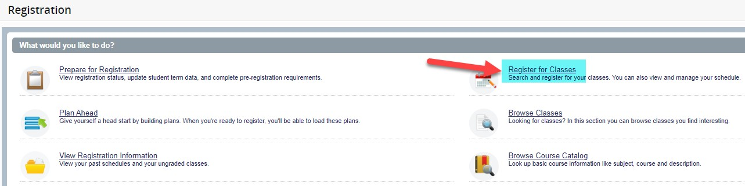

- Choose the term you want to register for (I'm using Fall 2023 as an example). Then click Continue.

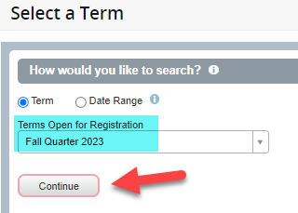

- You will see Plans tab, click it.
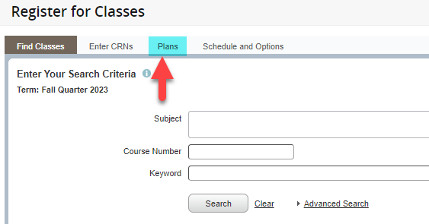

- You will see the options for every schedule you built. Identify the schedule you want and click the Add All button.

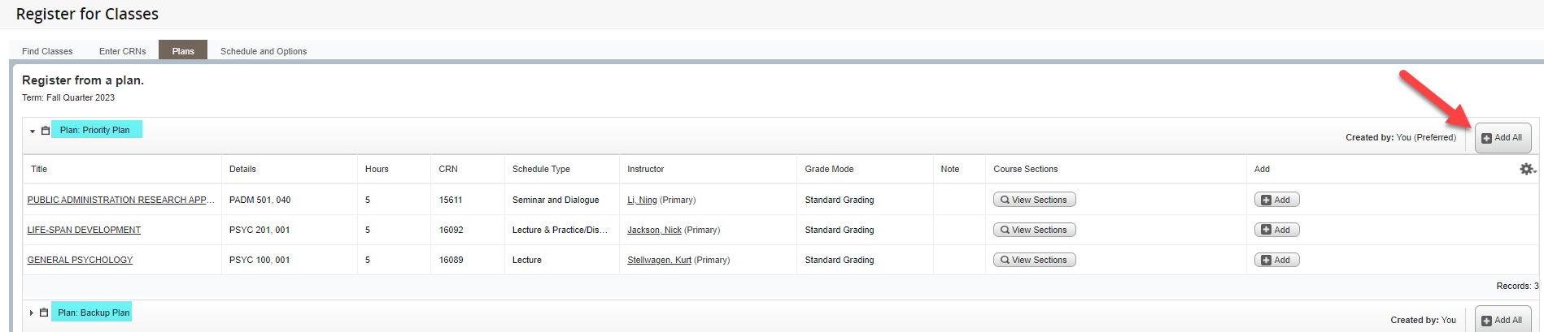

- You will see the courses get added on the bottom right. The Status column will say Pending. You must click on the Submit button on the bottom right in order to register into the courses.
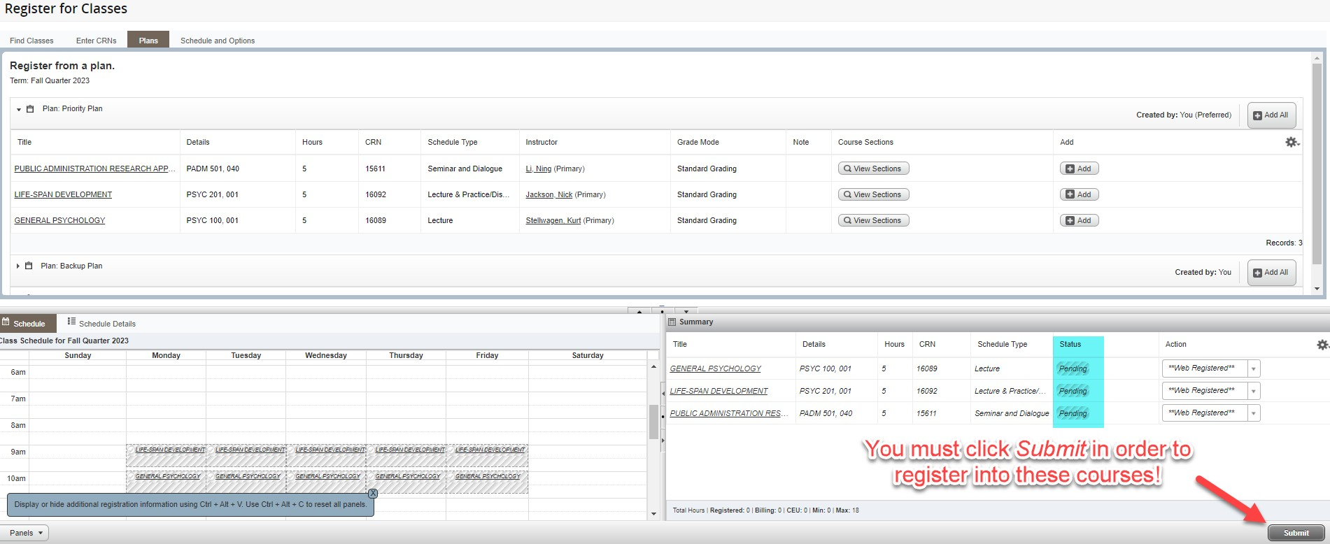
- After clicking Submit, you will see the Status update. If it is Green and says Registered, you are all set. If you see anything in Red, please connect with your advisor to determine the issue.
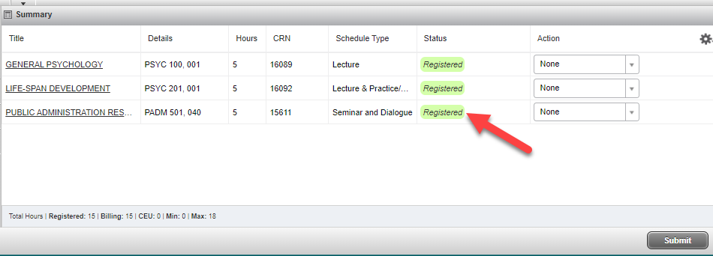

Once you get the Green Registered
status, you are registered!!

